How E. coli Grows
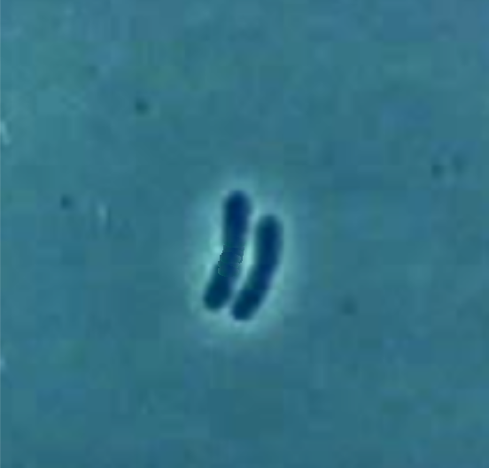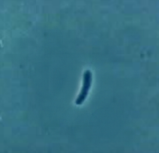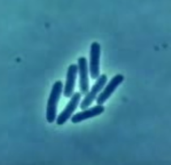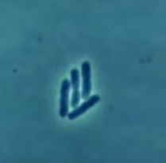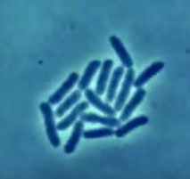
00:00:00
00:20:00
01:00:00
00:40:00
01:20:00
E. coli (Escherichia coli) is a type of bacteria that lives in the digestive tracts of humans and animals. It grows by splitting in half, through a process called binary fission.
What do you notice? | What questions do you have?
How E. coli Grows (part 2)
00:00:00
01:00:00
00:40:00
00:20:00
01:20:00
Imagine working as a scientist. You are growing E. coli in a petri dish. Every 20 minutes, you take a photograph through a microscope and then count the number of bacteria at that moment.
- What do you think the next photograph of bacteria would look like? (Draw them.)  01:40:00 | - Now, imagine 20 minutes have passed after the picture you drew on the left. How would you figure out how many bacteria there are now?

- Complete the table to the right.

- How many bacteria would there be after 4 hours?
- How many bacteria would there be after 5 hours?

