Measuring Actual Learning versus Feeling of Learning
in Response to Being Actively Engaged in the Classroom
Louis Deslauriers, Logan S. McCarty, Kelly Miller, Kristina Callaghan, and Greg Kestin
PNAS first published September 4, 2019 https://doi.org/10.1073/pnas.1821936116 [student-use adaptation]
Despite active learning being recognized as a superior method of instruction, a recent survey found that most college physics instructors still choose traditional teaching methods. This article addresses the question of why students and faculty remain resistant to active learning. Comparing passive lectures with active learning, we find that students in the active classroom learn more, but they feel like they learn less.
Researchers compared students’ self-reported perception of learning with their actual learning in large introductory college physics courses taught using:
- Active Instruction (Students work in small groups to discover and develop concepts and solve challenging problems.)
- Passive Instruction (Lectures and demonstrations are given by instructors while students listen, take notes, and are told how-to solve problems.)
Both groups received identical class content and handouts, students were randomly assigned to either class, and the instructor made no effort to persuade students of the benefit of either method.
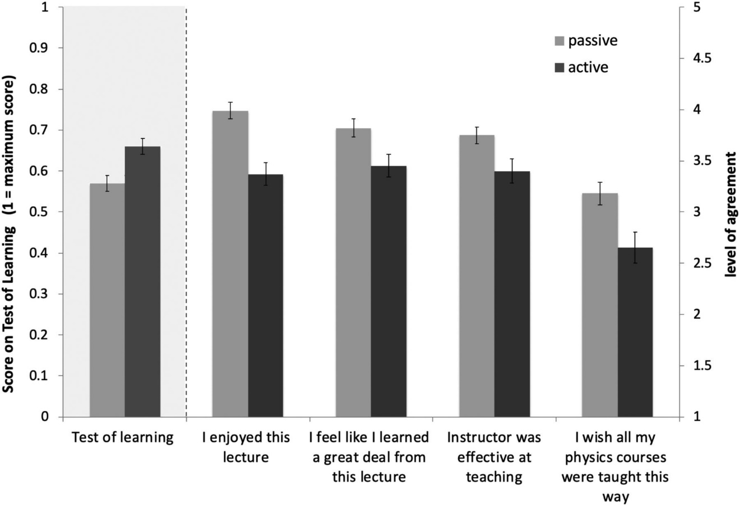

In the end, the research revealed that students in active classrooms learned more, but their perception of learning, while positive, was lower than that of their peers in passive environments. Most importantly, these results suggest that when students experience the increased cognitive effort associated with active learning, they initially take that effort to signify poorer learning. That disconnect may have a detrimental effect on students’ motivation, engagement, and ability to self-regulate their own learning. Although students can, on their own, discover the increased value of being actively engaged during a semester-long course, their learning may be impaired during the initial part of the course.
Students learn more when they are actively engaged in the classroom than they do in a passive lecture environment. Extensive research supports this observation. Research also shows that active teaching strategies increase attendance, engagement, and students’ acquisition of positive attitudes toward the subject. Despite this overwhelming evidence, most instructors still use traditional methods.
Why do these inferior methods of teaching persist? Instructors cite many obstacles preventing them from adopting active teaching strategies, such as insufficient time, limited resources, lack of professional support, concerns about covering content, and concerns about evaluations of their teaching. They also perceive that students resist active teaching strategies and prefer traditional methods.
Indeed, one-third of instructors who try active teaching eventually revert to passive lectures, many citing student complaints as the reason. Instructors report that students dislike being forced to interact with one another and resent the increase in responsibility for their own learning. More recent literature shows that if instructors explain and facilitate active learning, student attitudes toward it can improve over the course of a semester.
In this research, we identified an inherent student bias against active learning that can limit its effectiveness and may hinder the wide adoption of these methods. Compared with students in traditional lectures, students in active classes perceived that they learned less, while in reality they learned more. Students rated the quality of instruction in passive lectures more highly, and they expressed a preference to have “all of their classes taught this way,” even though their scores on tests were lower than those in actively taught classrooms.

