Section I: There are three kinds of plate tectonic boundaries:
Divergent, Convergent, and Transform plate boundaries.
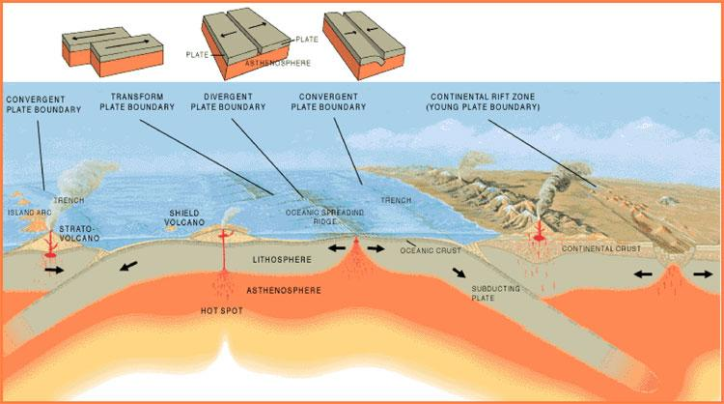
This image shows the three main types of plate boundaries: divergent, convergent, and transform. Image courtesy of the U.S. Geological Survey.

- A divergent boundary (oceanic-oceanic, continental-continental) occurs when two tectonic plates move away from each other. Along these boundaries, lava spews from long fissures and geysers spurt superheated water. Frequent earthquakes strike along the rift. Beneath the rift, magma—molten rock—rises from the mantle. It oozes up into the gap and hardens into solid rock, forming new crust on the torn edges of the plates. Magma from the mantle solidifies into basalt, a dark, dense rock that underlies the ocean floor. Thus, at divergent boundaries, oceanic crust, made of basalt, is created.
- When two plates come together, it is known as a convergent boundary (oceanic-continental, ocean-oceanic, continental-continental). The impact of the two colliding plates buckles the edge of one or both plates up into a rugged mountain range, and sometimes bends the other down into a deep seafloor trench. A chain of volcanoes often forms parallel to the boundary, to the mountain range, and to the trench. Powerful earthquakes shake a wide area on both sides of the boundary.

- Two plates sliding past each other forms a transform plate boundary. Natural or human-made structures that cross a transform boundary are offset—split into pieces and carried in opposite directions. Rocks that line the boundary are pulverized as the plates grind along, creating a linear fault valley or undersea canyon. As the plates alternately jam and jump against each other, earthquakes rattle through a wide boundary zone. In contrast to convergent and divergent boundaries, no magma is formed. Thus, crust is cracked and broken at transform margins, but is not created or destroyed.

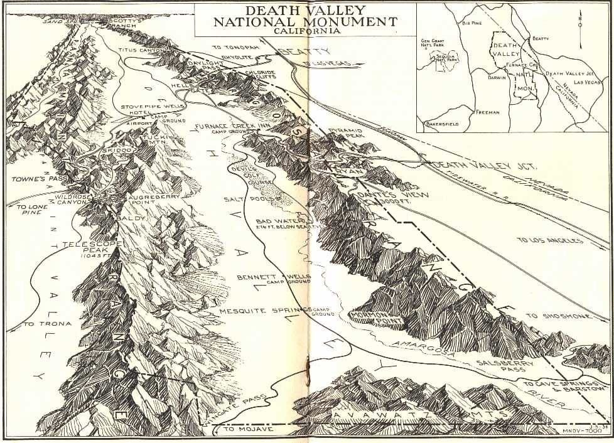
Death Valley, USA
What do you notice? What do you wonder?

What type of boundary do you think is shown below? Why?

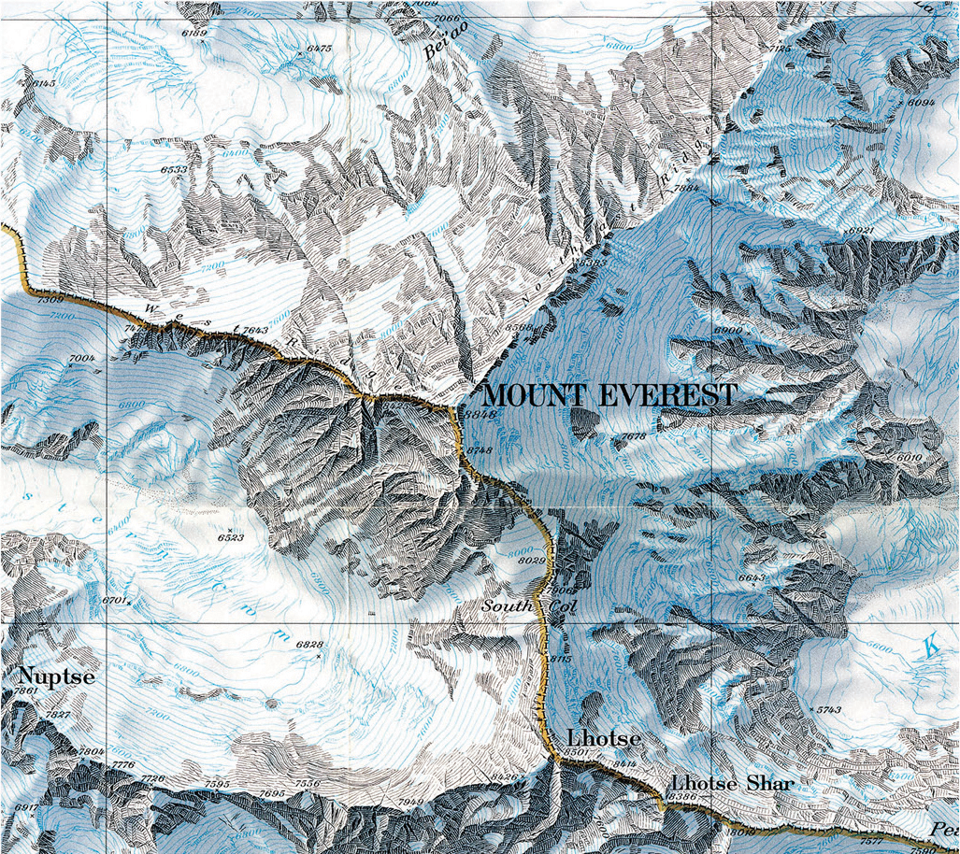
Mount Everest, Nepal/China
What do you notice? What do you wonder?

What type of boundary do you think is shown above? Why?

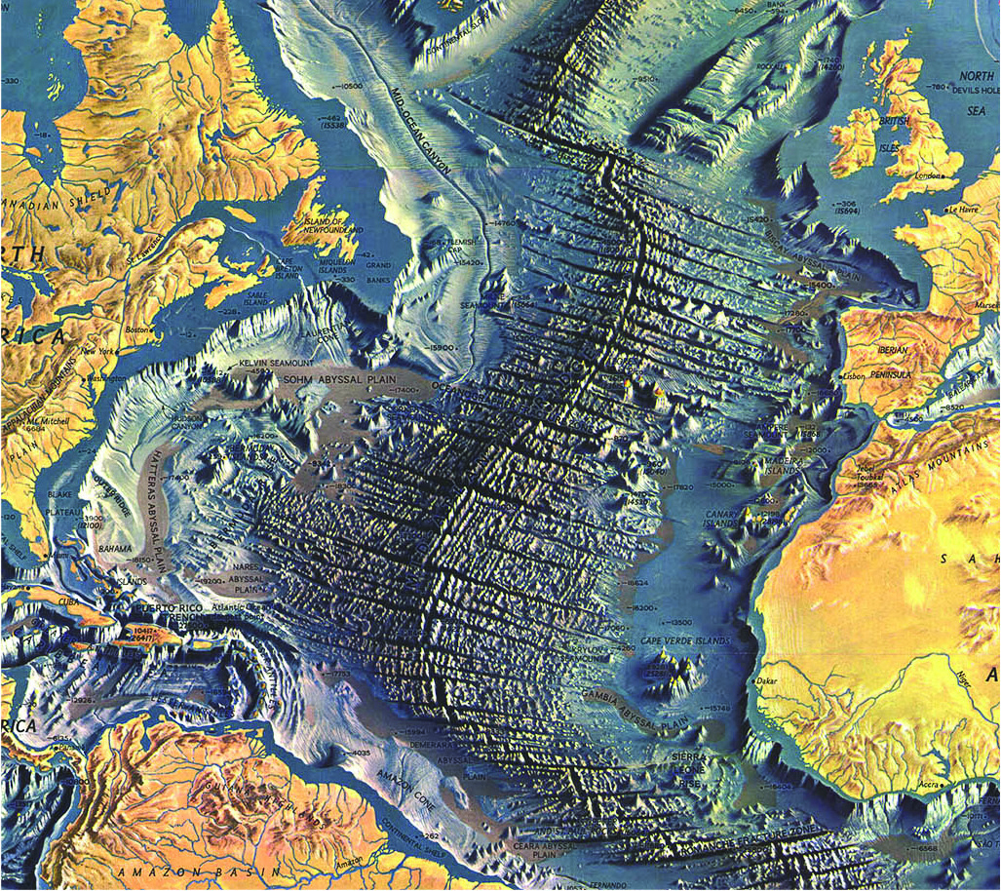
Mid Atlantic Ocean Ridge
What do you notice? What do you wonder?

What type of boundary do you think is shown below? Why?

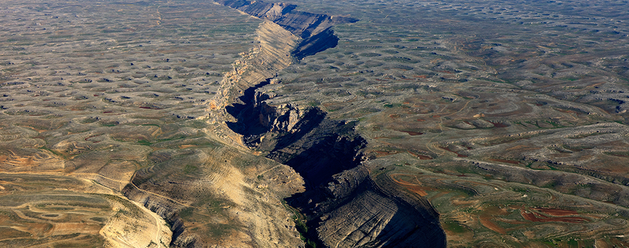
San Andreas Fault Line, USA
What do you notice? What do you wonder?

What type of boundary do you think is shown below? Why?

From NOAA

