How Being Bilingual Can Boost Your Career for pre-HSE Students
CUNY Career Fundamentals Career Kit Unit 1
(TABE 11/12 Focus)
Objectives:
- Students learn about the advantages of being bilingual in the workforce
- Students will discuss their own language(s) and their experiences learning new languages
- Students will practice reading a graph about languages
- Students will brainstorm and discuss the benefits of being bilingual in the workplace
- Students will be introduced to and work with vocabulary from the main text
- Students will answer reading comprehension questions about the main text
- Students will practice summarizing the main text
- Students will answer TABE-like practice questions based on the text and graph

Activity One: Using Graphs to Build Background Knowledge
Materials: Graph: “The World’s Most Spoken Languages” and Article: “These Are The World’s Most Spoken Languages”
Steps:
- Ask students if they know what the word “bilingual” means. (Definition: speaking two languages fluently.)
- Ask students to raise their hand if they speak a language other than English.
- Ask the students who raised their hand what other language(s) they speak and whether they are fluent in the language. (Suggestion: You can discuss what it means to be fluid; for example, not just knowing a few phrases.)
- If some/ no students raised their hand, ask students if they had to learn another language what language they would choose and why.
- Ask students to think about which language they think is the most spoken language in the world is. Write their responses on the board.
- Hand out the graph, “The World’s Most Spoken Languages” and ask students to review it silently.
- With a partner have students discuss: 1) What they notice in the graph and 2) What they’re curious about based on the information in the graph (i.e: What questions do you have about the graph? What don’t you understand about the graph?).
- Bring the class back together and discuss question one; write their responses on the board and evaluate any inaccurate responses. Then discuss question two; allow other students to address question two before giving students any answers.
- Hand out the article, “These Are The World’s Most Spoken Languages.” Ask students to read the article silently to themselves.
- Once students have read the article, bring the class together and ask for volunteers to read the article aloud. (Suggestion: you may want to assign one volunteer to each of the three sections of the article. )
- Ask students what they were most surprised to learn after reviewing the graph and reading this article.
- Hand out the multiple choice questions and give students a few minutes to answer the questions on their own.
- Bring the group back together and review the questions and the answers. (Suggestion: Take a poll to find out how many questions students got correct.)

Activity Two: Practicing Re-reading and Learning How Being Bilingual Can Benefit Your Career?
Materials: “How Being Bilingual Can Boost Your Career,” (Career Fundamentals, Unit 1: Today’s Labor Market, page 62) “Vocabulary List,” “Understanding How Being Bilingual Can Boost Your Career”
Steps:
- Tell students that we will continue the discussion about languages by looking at
how being bilingual--speaking two languages fluently--can be an advantage in the
workplace.
15. Place students in groups of three (or four depending on class size) and ask them to
come up with a list of ways being bilingual can be an advantage at work (five to six
responses). (Suggestion: Tell them to jot down their answers on a blank sheet of
paper and be prepared to share their answers with the class.)
16. Bring the class back together and ask for volunteers to share what they discussed in
their groups. Make a list of their responses on the board.
17. Tell students that they’re going to read an article on how being bilingual can boost a
person’s career but first they’re going to look at some vocabulary from the article.
18. Place students in groups of three or four, then hand out the vocabulary list sheet.
Tell students that they should work together to come up with a working definition
of the word and then a synonym for the word without using the internet or a dictionary. Tell students it’s okay if they can’t fill in all of rows on the vocabulary list or if they can think of a definition but not a synonym and vice versa. (Note: This lesson assumes that students are familiar with the term synonyms and have discussed synonyms prior to this lesson.) Circulate the room as students work helping them where/ when needed.
19. Bring the class back together and discuss the words on the vocabulary sheet filling
in gaps and clearing up in accuracies when necessary. (Suggestion: Duplicate the
vocabulary list chart on the board and fill it in with student responses. )
20. Hand out the article “How Being Bilingual Can Boost Your Career” and tell students
to preview the text by describing what they notice about it before they even start
reading it. (Note: If the concept of “previewing the text” is new to students, prompt
them by asking them questions like: how many paragraphs does the article have or
what they notice about the picture in the article.)
21. Tell students to read the article silently to themselves with a pen/pencil in hand.
Tell students that they should underline any confusing words as they read and/ or
put a question mark next to any sections of the text that is confusing to understand.
(Note: Students should not stop to look up confusing words but just underline them
and keep on reading.)
22. As a class, discuss which words students underlined and the definitions of
those words (allow students to look them up online, on their phone, or in a
dictionary if preferred).
23. Tell students that they will read the article again, aloud, now that they have
addressed any confusing vocabulary. Assign one student to each paragraph in the
article and have them read aloud to the class. Then ask students to review the
sections they marked with question marks to see if they are still confused. Discuss
sections of the text that are still confusing to students.
24. Hand out “Understanding How Being Bilingual Can Boost Your Career” and have
students work on the questions in pairs. Then discuss student responses as a whole
class.

Activity Three: Summarizing A Text
Materials: “How Being Bilingual Can Boost Your Career”
Steps:
- (Note: Students should have already been introduced to the concept of summarizing.) Tell students that they will create a class summary of the article by coming up with a one-sentence summary for each paragraph.
- Tell students that re-reading the article, paragraph by paragraph, and determining the main idea of each paragraph will be helpful in creating a summary of the entire article.
- Ask for a volunteer to read paragraph one aloud while the class reads along silently. Then discuss what the paragraph is saying distinguishing important from unimportant ideas.
- Ask students what you should write as a summary sentence for this paragraph; begin to formulate a sentence on the board as students provide suggestions. Revise the sentence as necessary by pointing out any errors in syntax, grammar, and punctuation. (Note: If students are struggling to begin the summary, provide a sentence starter. For example, “One of the most important skills…” or “Speaking more than one language is…”)
- Repeat step four until you have a one-sentence summary for each paragraph. Call students’ attention to any areas of the summary that need smoother transitions or are not quite accurate based on the text.
- Hand out the TABE practice questions and give students a few minutes to answer the questions. Then bring the class back together to review the answers.

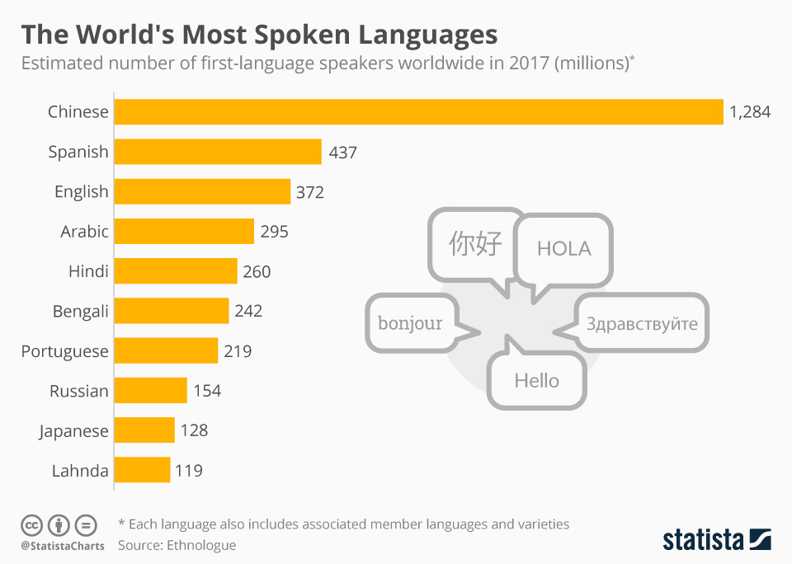

These Are The World’s Most Spoken Languages

La langue, Sprache, 語言.

However you say it, we all speak at least one. In fact, more than a quarter of us speak one of just three languages as our native tongue, according to data from Ethnologue, a database of languages.

That’s three languages between more than 2 billion people.

Those three, and the rest of the top 10 most spoken languages in the world, are all shown in this chart by Statista.

Chinese leads the way

It’s probably no surprise that Chinese tops the ranking. Nearly 1.3 billion people speak a form of Chinese as their first language. This includes more than 10 varieties; some that you’ve heard of, such as Mandarin, and others, such as Pu-Xian, that you might be unfamiliar with.

Spanish takes second place – and you’re part of a big club if you speak it: 437 million other people, mostly in Spain, Latin America and parts of the US, are also members.

English takes bronze, although it’s far more widely spoken than Spanish or Chinese, according to Ethnologue. English is established in 106 countries, compared to 37 for Chinese and 31 for Spanish.

It’s worth remembering, though, that these numbers are always changing, and our knowledge of the world’s languages is constantly being refined. The Ethnologue data represents one approximation of the situation.
Lonely languages

Speaking a language can be a lonely business.

There are over 1,000 languages with between 100 and 999 speakers, more than 300 with between 10 and 99, and 114 with nine speakers or less.

These 114 languages have so few speakers you could fit them in Barcelona’s Camp Nou stadium – 170 times.

Adapted from The World Economic Forum website.
Vocabulary for How Being Bilingual Can Boost Your Career

Directions: Discuss each word in your group and come up with a working definition of the word and one or more synonyms for each word.

Vocabulary Word | Working Definition | Synonym
Efficiency

Punctuality

Characteristics

Significant

Booming

Sectors

Expanded

Bicultural

Troubleshoot

Array

TABE Reading Questions for “These Are The World’s Most Spoken Languages”

- The topic of this article is:
A. Languages with 9 speakers or less.
B. Over a billion people speak Chinese.
C. The most spoken languages in the world.
D. Ethnologue collects data about languages.

2A. Which of these is the main idea of the article?
A. Chinese, Spanish, and English are the top three languages spoken in the world.
B. Most people speak more than one language fluently.
C. Almost 1.3 billion people speak some form of Chinese.
D. The number of people who speak a certain language is always changing.

2B. Which sentence from the article best supports the answer to part A?
A. “However you say it, we all speak at least one.”
B. “In fact, more than a quarter of us speak one of just three languages as out native
tongue, according to data from Ethnologue….”
C. “It’s probably no surprise that Chinese tops the ranking.”
D. “Speaking a language can be a lonely business.”

3. Read this sentence from the article.
“This includes more than 10 varieties; some that you’ve heard of, such as Mandarin, and others, such as Pu-Xian, that you might be unfamiliar with.”

Which words means the same as varieties as it is used in the sentence?
A. types
B. harmonies
C. similarities
D. usages

4. According to the article, which of these best explains why 1.3 billion people speak some
form of Chinese?
A. China is a very big country.
B. English is only established in 106 countries.
C. Chinese has more than ten varieties.
D. A lot of people learn Chinese as a second language.

TABE Reading Questions for “These Are The World’s Most Spoken Languages”
Answer Key

- The topic of this article is:
A. Languages with 9 speakers or less.
B. Over a billion people speak Chinese.
C. The most spoken languages in the world.
D. Ethnologue collects data about languages.

2A. Which of these is the main idea of the article?
A. Chinese, Spanish, and English are the top three languages spoken in the world.
B. Most people speak more than one language fluently.
C. Almost 1.3 billion people speak some form of Chinese.
D. The number of people who speak a certain language is always changing.

2B. Which sentence from the article best supports the answer to part A?
A. “However you say it, we all speak at least one.”
B. “In fact, more than a quarter of us speak one of just three languages as out
native tongue, according to data from Ethnologue….”
C. “It’s probably no surprise that Chinese tops the ranking.”
D. “Speaking a language can be a lonely business.”

3. Read this sentence from the article.
“This includes more than 10 varieties; some that you’ve heard of, such as Mandarin, and others, such as Pu-Xian, that you might be unfamiliar with.”

Which words means the same as varieties as it is used in the sentence?
A. types
B. harmonies
C. similarities
D. usages

4. According to the article, which of these best explains why 1.3 billion people speak some
form of Chinese?
A. China is a very big country.
B. English is only established in 106 countries.
C. Chinese has more than ten varieties.
D. A lot of people learn Chinese as a second language.

TABE Reading Questions for “How Being Bilingual Can Boost Your Career”

- Read this sentence from the passage.
“So which languages can give you a leg up on the job market?”

Which of these best explains the meaning of the phrase “a leg up” in the
sentence?
A. Help someone get on a horse.
B. Put one foot in front of the other.
C. To have an advantage over someone else.
D. To be informed about the job market.

2. The purpose of this article is to:
A. entertain
B. inform
C. describe
D. persuade

3. How does paragraph 2 contribute to the development of the ideas in the passage?
A. It presents information about skills an employer should have.
B. It explains how being bilingual can be an advantage in the workforce.
C. It describes what happens when a company hires a bilingual person.
D. It states how business leaders feel about bilingual people.

4. Which of these best states the author’s opinion about being bilingual?
A. Everyone should be bilingual.
B. Being bilingual can make someone more valuable to an employer.
C. Only a few fields need people who are bilingual.
D. Non-bilingual employees are not very valuable to employers.

5. Read this sentence from the article.
“As immigration increases, the demand for bilingual Healthcare workers is
growing.”

Which word means the same as increases as it is used in the sentence?
A. escalates
B. decreases
C. widens
D. rises

TABE Reading Questions for “How Being Bilingual Can Boost Your Career”
Answer Key

- Read this sentence from the passage.
“So which languages can give you a leg up on the job market?”

Which of these best explains the meaning of the phrase “a leg up” in the
sentence?
A. Help someone get on a horse.
B. Put one foot in front of the other.
C. To have an advantage over someone else.
D. To be informed about the job market.

2. The purpose of this article is to:
A. entertain
B. inform
C. describe
D. persuade

3. How does paragraph 2 contribute to the development of the ideas in the passage?
A. It presents information about skills an employer should have.
B. It explains how being bilingual can be an advantage in the workforce.
C. It describes what happens when a company hires a bilingual person.
D. It states how business leaders feel about bilingual people.

4. Which of these best states the author’s opinion about being bilingual?
A. Everyone should be bilingual.
B. Being bilingual can make someone more valuable to an employer.
C. Only a few fields need people who are bilingual.
D. Non-bilingual employees are not very valuable to employers.

5. Read this sentence from the article.
“As immigration increases, the demand for bilingual Healthcare workers is
growing.”

Which word means the same as increases as it is used in the sentence?
A. escalates
B. decreases
C. widens
D. rises

