Core Problem Overview: The Commission Problem
The Commission Problem creates a situation in which a married couple—Eric and Nancy—sell fish tanks for competing companies. Eric is paid a monthly salary of $1400 and a commission of $75 for each fish tank that he sells. Nancy is not paid a monthly salary, but her
commission is much higher; she earns $250 per fish tank. In working on the Commission Problem, students will first make a choice about whose job is better based on the numbers.
After students have had time to share their initial thoughts, they will work to find how many fish tanks each person would need to sell in a given month so that they both earn the same amount of money. Students should be given time to struggle with the problem, and you should support any method that the student has chosen. However, you should try to help struggling students organize their information into a table.
The sample of work below shows a table used by a student to solve the problem. Not all students will create a table like this one, but during the processing part of the activity, you want to make sure that any students with tables that resemble input/output tables go to the board and to share their work with the group. You really want the table to come out. If no students use this method, the teacher should share it, but only after students have presented and commented on their own strategies.
In the end, all students should understand that Eric and Nancy will make the same amount of money in a month when they both sell eight fish tanks.
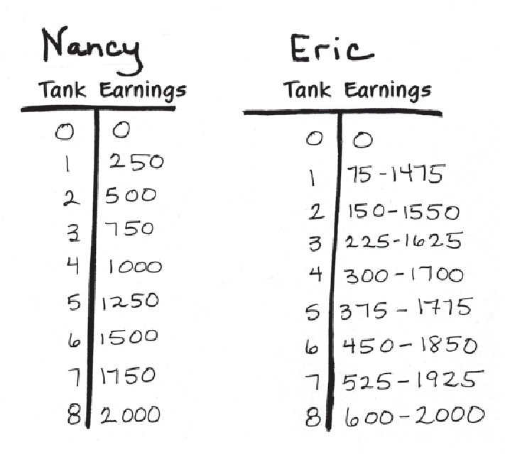That is the point that will stand out to students on the graph. That said, there is more than one answer to this problem the way it is phrased. Eight fish tanks is
the number of tanks Eric and Nancy need to sell to earn the same amount of money and sell the same number of fish tanks.
There are other ways for them to earn the same amount. For example, if Eric sells 18 tanks and Nancy sells 11, they would both earn $2750. If Eric sells 28 tanks and Nancy sells 14, they would both earn
$3500. Teachers can use this fact as an extension problem for students and ask, Are there any other ways for them to earn the same amount of money?

For the last part of the activity, distribute the graph showing Eric’s income alongside Nancy’s income. Notice that the graph does not indicate which line represents Eric and which represents Nancy. The goal is for students to figure this out on their own, with some support from you. You should first give students five minutes to look at the graph on their own, and then lead a whole-class discussion about
the information represented in the graph. By the end of the activity, students should be able to identify which line represents each person, and they should also be able to extract information from the graph, such as how much money the couple would make if they each sold twelve fish tanks. You also want to have students spend some time talking about the significance of the point where the two lines intersect. Depending
on the level of the class, you might choose to ask students to create a function rule for Eric and Nancy. If students are not ready to do so at this point, you can return to the tables and graph for the Commission Problem after Unit 3: Rate of Change.

TEACHING THE CORE PROBLEM
During the first part of the activity, in which students decide who has a better job, you should help students to understand the problem by asking clarifying questions. Some examples are:
- Tell me about what this problem is asking. Can you put it into your own words?
- How much would Nancy make if she didn’t sell any fish tanks? How much would Eric make?
- I see you think that Eric/Nancy has the better job. Can you tell me how you decided that?
Once all students have made a decision and justified it in writing, ask the class to vote on who has a better deal, and write the tally on the board. Students who say that Eric does may point out that he will still make money in a month when he isn’t able to sell any fish tanks, whereas Nancy would make nothing. They may also note that Nancy will always have to work a little bit harder, since her income is solely dependent on the number of fish tanks that she sells. Students who say that Nancy has a better job might say that she has the potential of making more money in a month than Eric since she makes more
in commission per fish tank. At this point in the activity, do not tell students that their choice is right or wrong; instead he or she should allow time for the students to justify their choices and talk to one another about the problem. You might hold a few different votes and see if any of the arguments reverse an opinion or two. If they do, ask the

student who changed their vote to explain what they found compelling about the argument that swayed them.
Then direct students to the question on the second page. Students should be given ample time to work individually before they discuss their findings with classmates. While the students are working, continue to support their individual problem-solving efforts through questioning. Some students will use guess-and-check to get started on the problem, and you should support this method as much as possible. If students get frustrated while trying this approach, ask if there is a way to organize all of these guesses. Ideally, this will result in students creating a table of some kind. As students are working, the teacher should check in
with each student and ask them to explain their thinking, how they got started, and what aspects of the problem they are struggling with. Some students will forget to figure Eric’s salary into his income. You will need to help these students get back on track without giving too much away.

PROCESSING TH E PROBLEM
After all students have solved the problem through guess and check, creating a table, or a combination of these methods, the teacher should lead the class in a discussion of solution strategies. The teacher should select three or four students to talk about their work and show it on the board or on chart paper. During the presentation of solution strategies, ask questions that help the class process the solution method being demonstrated:
  - What do you like about this method?
  - How do we know that this answer is correct?
  - Have we seen a table like this before? Where?
  - How do the tables connect to the function machines from the previous unit?
  - Does this change your opinion of who has a better deal? Why?
Now that the class has talked about solution strategies, distribute the graph of Eric and Nancy’s salaries. Ask the class to silently study the graph for a few minutes on their own. After looking at the graph for a few minutes, at least one of the students should notice that the numbers match those that they were working with in solving the problem. Some questions to help students process the graph are:
  - Which line represents Eric? Which represents Nancy? How do you know?

- Why does Eric’s line start higher than Nancy’s line?
- Who would make more in a month when both Eric and Nancy sold four fish tanks? How much more?
- How much would Eric make if he sold twelve fish tanks? How much would Nancy make?
- Which line is changing faster? Does that make sense given the information in the problem?
- What do you notice about the difference in their earnings if they each sell 16 fish tanks?
Take this opportunity to introduce the term axis and coordinate when talking about specific data points on the graph. Add a third column
to the tables from the Commission Problem and have students write in the ordered pairs. Students should then be asked to label the axes “Earnings” or “Income” and “Number of Fish Tanks Sold.”

SU PPLEMENTAL PROBLEMS
The supplemental problems in this unit build upon the core problem by helping students become familiar with plotting points and lines in a one- quadrant graph. Depending on the students’ familiarity with graphing and their struggles during the commission problem, the teacher may choose to use some or all of these problems in the classroom. Some may also be assigned for homework.
- The Three Views of a Function
These problems offer practice for generating a table based on a rule, creating coordinates, and then plotting them in the plane. Students should be guided to connect the dots to form lines, and they should talk about similarities and differences in the graphs that they have created.
- Cooking with Functions
This problem builds upon the Three Views of a Function worksheet by asking students to think about the correct ratio of water to rice when cooking. Some of the data points will form a line representing the correct 2:1 ratio, while others will fall either above or below the line. These are points that do not fit the function rule. Students will be asked to make conclusions about each of the points. For example, one of the points is located at (3, 2). This point falls above the line. By analyzing the graph and the ratio, students should see that there is not enough water, and therefore the rice will be too crunchy, or too dry. It is also interesting to ask students what they notice about the points that are above the line and those that fall below it.

  - The Cab Fare Problem
In this problem, students will need to use data to construct a graph and draw a conclusion about how a taxi company calculates the total fare for a ride. Students are given information from three riders. They will need to plot the points, identify a linear relationship, and draw conclusions about what the fare would be for other travel distances.

Core Problem

The Commission Problem
Eric and Nancy are married, and they work part-time as salespeople for two different companies. They both sell fish tanks to high-end restaurants in the New York City metro area. Eric’s employer pays him a monthly salary of $1400, plus a commission of $75 for every fish tank that he sells. Nancy’s employer does not pay her a salary. Instead, they offer her a commission of $250 for every fish tank that she sells.
Nancy tells Eric that she has a better deal than he does, because she makes more money on each fish tank that she sells. Eric says this isn’t true. “I have a better deal,” he says, “because I get paid even if I sell zero fish tanks.”
Who is right? Why?

unit • 2 teacher support / handout 1 pg. 2

The Commission Problem, Part 2
Eric and Nancy want to contribute equally to their finances.
How many fish tanks would they each need to sell so that they bring in the same amount of money?

The Commission Problem

