Taxi Cab Problem – Practice Test Versions
Four friends used the same taxi service to meet at a restaurant for dinner. When they arrived at the restaurant, they compared their cab fare and tried to figure out a rule that the taxi company used to calculate cost.
Passenger | Distance  (in miles) | Cost
Denise | 1 | $4.50
Mark | 6 | $12
Solange | 3 | $7.50
Kate | 8 | $15
- Which linear function models the relationship between the number of miles driven, m, and the cost of the cab ride, C?
  - C = 4.5m
  - C = 2.5m
  - C = 1.5m + 3
  - C = 3m + 1.50
- Which linear function models the relationship between the number of miles driven, m, and the cost of the cab ride, C(m)?
  - C(m) = 4.5m
  - C(m) = 2.5m
  - C(m) = 1.5m + 3
  - C(m) = 3m + 1.50
Four friends used the same taxi service to meet at a restaurant for dinner. When they arrived at the restaurant, they compared their cab fare and figured out they could calculate the cost of a ride using the following function: C = 1.5m + 3, where m is the number of miles traveled and C is the cost of the ride.
Passenger | Distance  (in miles) | Cost
Denise | 1 | $4.50
Mark | 6 | $12
Solange | 3 | $7.50
Kate | 8 | $15
- Which statement is true about the cab fare?
  - The ride costs $4.50 for each mile.
  - The ride costs $3.00 for each mile driven plus $1.50
  - For each 10 miles driven, the cab ride costs $18.00
  - The ride costs $1.50 for each mile plus a flat fee of $3.00
- Halfway through the meal, Isabel arrives. She used the same taxi service and paid $22.50 for the ride.
What distance did she travel?
- A taxi company uses the function C(m) = 1.5m + 3 to calculate the cost of a taxi ride.
- C(m) is the total cost (in dollars) of the ride
- m is the number of miles traveled
What do the values 1.5 and 3 represent in the function?
  - The cost to ride a taxi 3 miles is $1.50.
  - The cost to ride a taxi 1.5 miles is $3.00.
  - The cost of a taxi is $1.50 plus $3.00 per mile.
  - The cost of a taxi is $3.00 plus $1.50 per mile.
- Four friends used the same taxi service to meet at a restaurant for dinner. The graph to the right shows the distance traveled, in miles, and the cost of each friends’ ride.
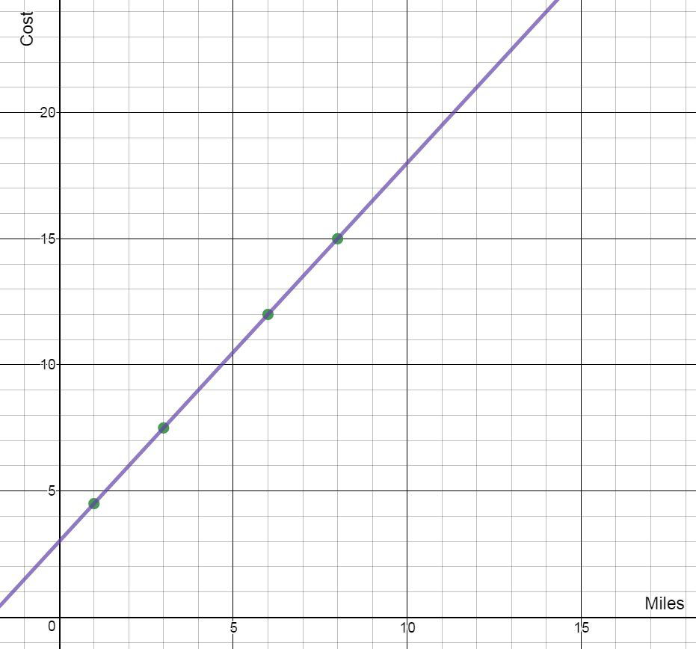
If C is the cost of a ride that is m miles, which function can be used to calculate the cost of a taxi ride?
  - C = 4.5m
  - C = 2.5m
  - C = 1.5m + 3
  - C = 3m + 1.50
- How much would it cost to ride for 10 miles?

