Condo Challenge
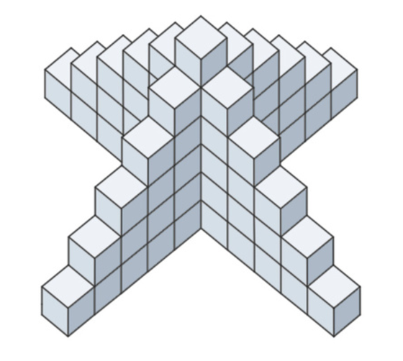
Building planners are designing a new condo building. They develop the model to the right, with each small cube representing a condominium.

1. How many cubes are needed to build the six-condo high model of Quadratic Condominiums shown to the right?

2. How many cubes would be needed to build a twelve-cube high model?

3. Explain how you got your answers for the first and second questions. Can you think of any other ways of solving this problem?

4. How could you figure out how many cubes would be needed to build a model of any height?

5. How could your findings help the builders of Quadratic Condominiums?

