Which Measurement Impacts the Volume More?
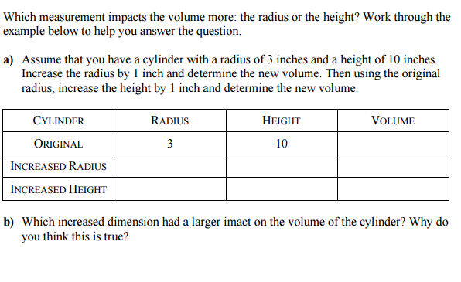

Adapted from NCTM Illuminations

