Find the volume of our cylinders
As you share your popcorn snack, answer the questions below:
- Was your prediction correct? Were you surprised?

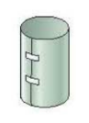
- Calculate the volume of the wider cylinder. Use the ruler to gather any relevant information. Label the dimensions in the figure.
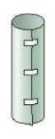

- Calculate the volume of the taller cylinder. Use the ruler to gather any relevant information. Label the dimensions in the figure.

- Explain why the cylinders do or do not hold the same amount.

