# HSE-Style Questions Aligned to CUNY HSE Curriculum Framework Section 4, Mathematics, Unit 1 – Introducing Functions

1. Which of these tables of values represents a function?
   1. B.

|  |  |
| --- | --- |
| Input | Output |
| 3 | 2 |
| 9 | 4 |
| -6 | 8 |
| 3 | 9 |

|  |  |
| --- | --- |
| Input | Output |
| -4 | 8 |
| -2 | 4 |
| 0 | 0 |
| -2 | -4 |

C. D.

|  |  |
| --- | --- |
| Input | Output |
| 8 | 6 |
| 6 | 8 |
| 4 | 8 |
| 8 | 4 |

|  |  |
| --- | --- |
| Input | Output |
| 2 | 6 |
| 8 | 24 |
| 10 | 30 |
| -6 | 9 |

1. Which of these sets of ordered pairs represents a function?

A. {(3, -2), (4, 1), (5, -1), (6, 9)}

B. {(6, -8), (6, -3), (6, 3), (6, 2)}

C. {(9, 2), (5, -1), (9, -1), (8, 10)}

D. {(3, -1), (8, 1), (8, 3), (1, 9)}

1. Which of these sets of ordered pairs represents a function?

A. {(6, -1), (4, 2), (5, -1), (6, 1)}

B. {(2, -8), (5, -3), (4, 3), (5, 2)}

C. {(2, -1), (5, -1), (3, -1), (7, -1)}

D. {(8, -1), (8, 1), (8, 3), (8, 9)}

1. Which of these sets of ordered pairs does NOT represent a function?

A. {(6, -1), (4, 2), (5, -1), (9, 1)}

B. {(2, -8), (3, -3), (4, 3), (5, 2)}

C. { , 8 , (5, -1), (3, -8), (0.5, -1)}

!

!

D. {(2, -1), (8, 1), (3, 3), (19, 9)}

1. Which of the following does NOT represent a function?

A.

Input Output 11 -2

12 -1

13 7

20

B.

Input Output 11 -2

12 -1

13 7

20

C.

Input Output 11 -2

12 -1

13 7

20 9

D.

Input Output 11 -2

12 -1

13 7

20

1. Which of these tables of values does NOT belong to a function?
   1. B.

|  |  |
| --- | --- |
| Input | Output |
| 0 | 2 |
| 0.5 | 4 |
| -6 | 2 |
| 3 | 7 |

|  |  |
| --- | --- |
| Input | Output |
| -1 | 8 |
| -2 | 3 |
| 0 | 0 |
| -!  ! | -4 |

C. D.

|  |  |
| --- | --- |
| Input | Output |
| 0.8 | 6 |
| 6 | 8 |
| 8 | 3 |
| 1 | 4 |

|  |  |
| --- | --- |
| Input | Output |
| !  ! | 6 |
| 8 | -28 |
| 10 | 19 |
| 0.25 | 3 |

1. Given the relation G = {(-4, 5), (8, 2), (*a*, 7), (1, 3)}. Which replacement for *a* makes this relation a function?
   1. 1
   2. 2
   3. -4
   4. 8

# HSE-Style Questions Aligned to CUNY HSE Curriculum Framework Section 4, Mathematics, Unit 2 – Three Views of a Function

1. Which graph models the function that has (0, 3), (-2, -1), and (1, 5) included in its solution set?
   1. 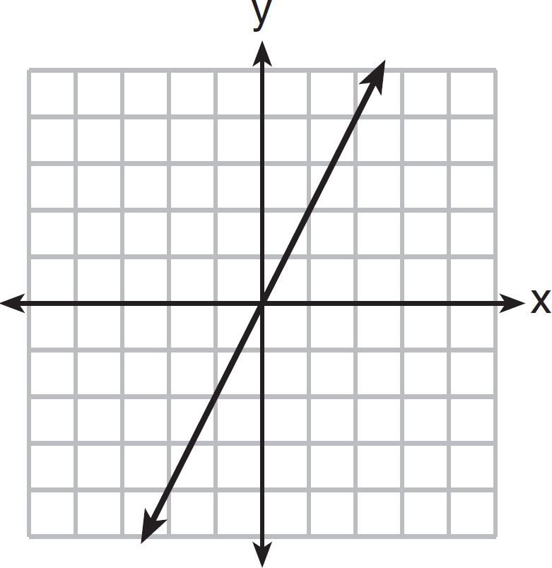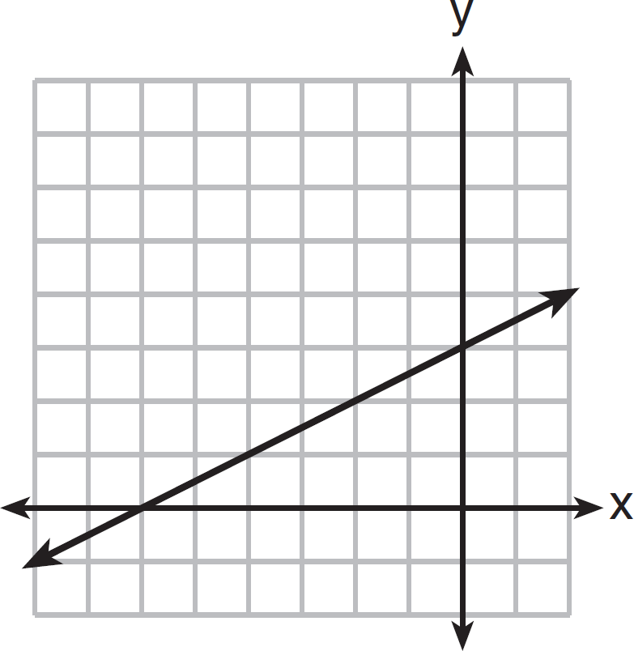B.

C. D.

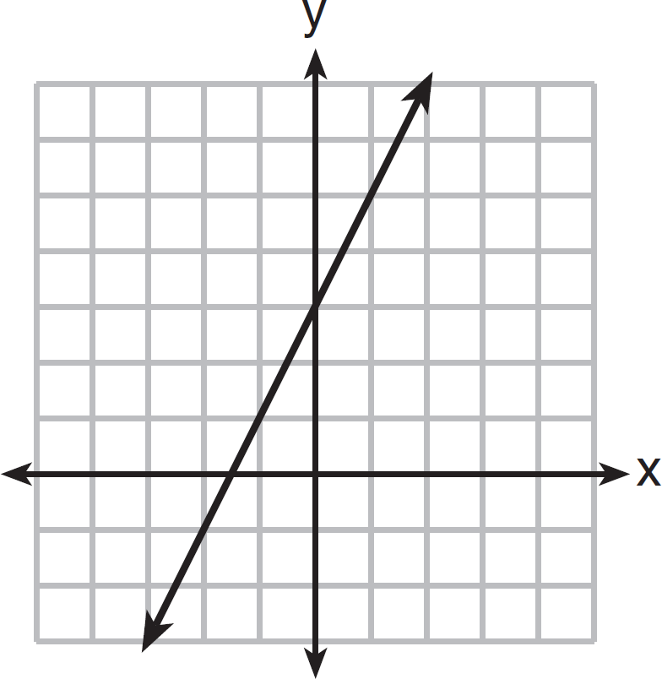 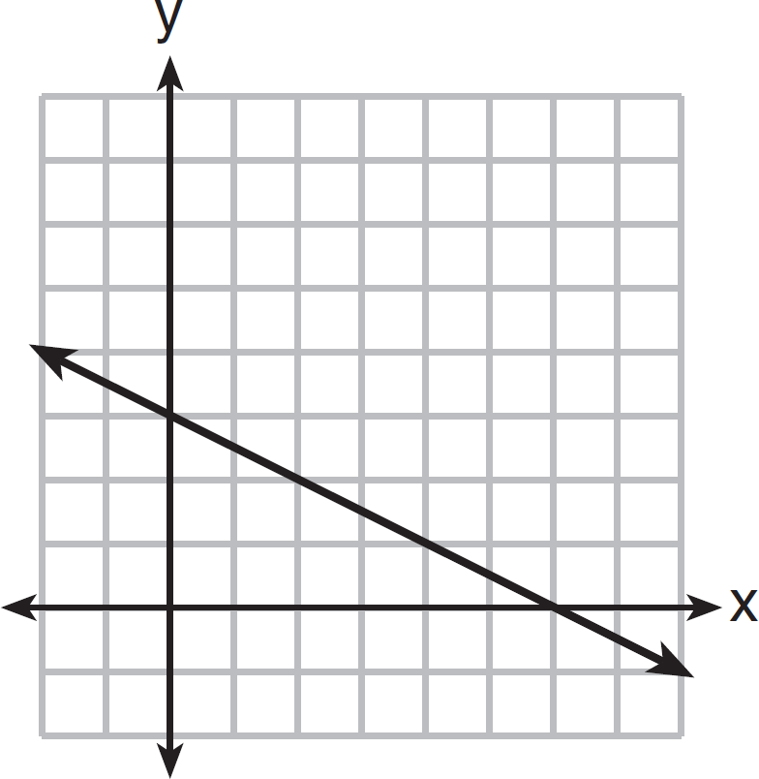

1. Which of the following solutions would NOT belong to the solution set for the linear function associated with the table of values below?

A. (0, 3)

|  |  |
| --- | --- |
| ***x*** | ***y*** |
| 1 | 4 |
| 3 | 6 |
| 5 | 8 |
| 7 | 10 |

B. (2, 5)

C. (6, 7)

D. (8, 11)

1. Which of the following solutions would belong to the solution set for the linear function associated with the table of values below?

A. (3, 7)

|  |  |
| --- | --- |
| ***x*** | ***y*** |
| 4 | 11 |
| 5 | 15 |
| 6 | 19 |
| 7 | 23 |

B. (1, 8)

C. (6, 16)

D. (8, 24)

1. 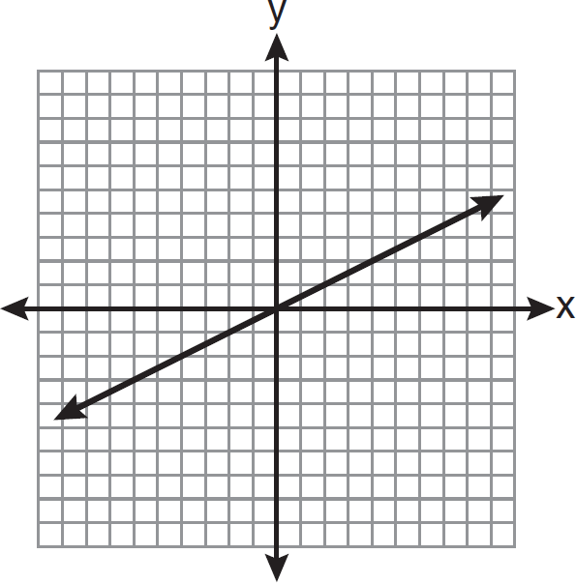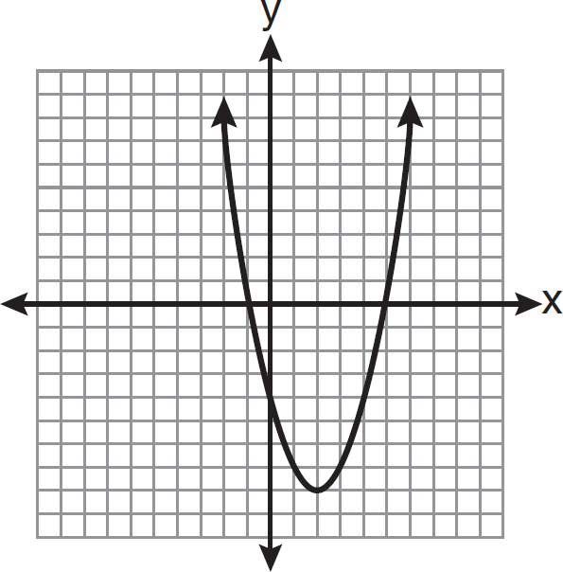Which graph models the function that has (2, 1), (-4, -2) and (6, 3) included in its solution set?
   1. B.

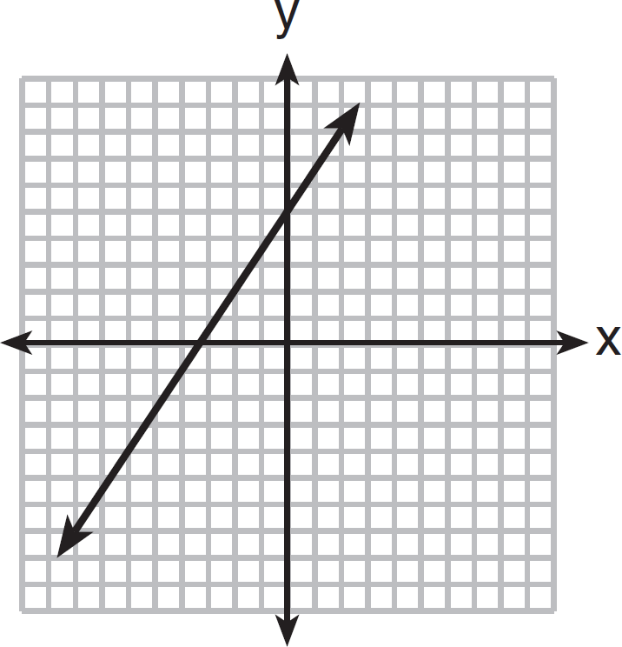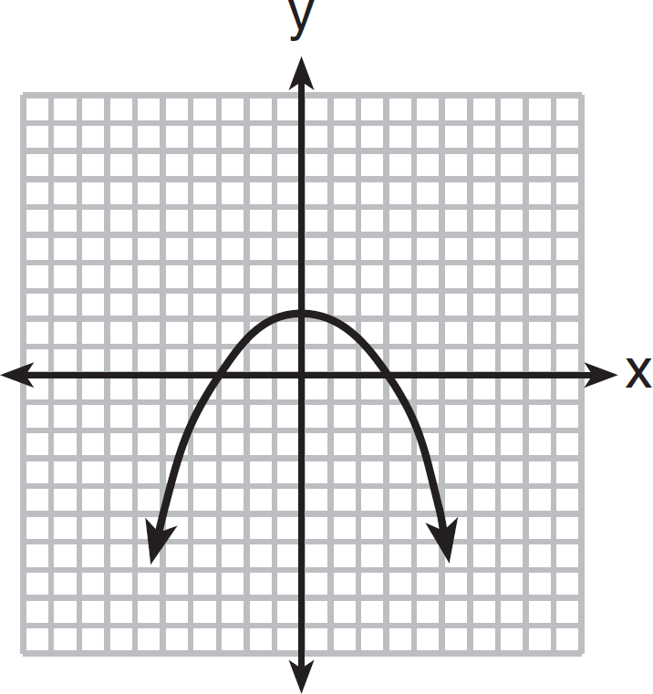C.

D.

1. Refer to the graph below.

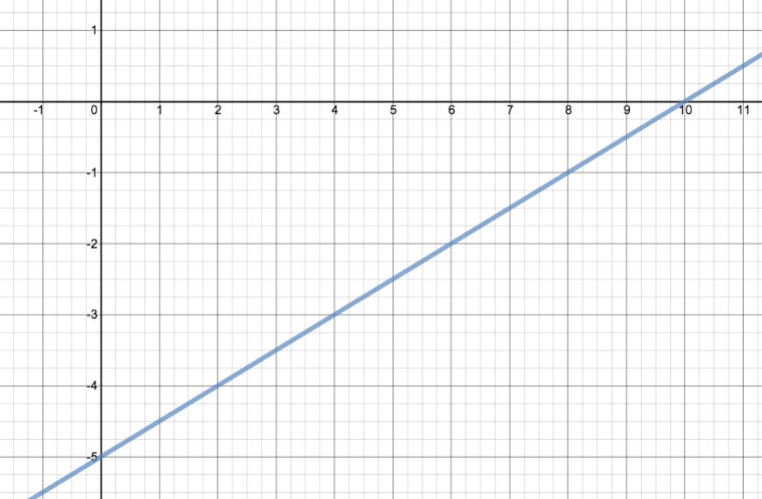

Which table includes three solutions that lie on the graph above?

* 1. B. C. D.

|  |  |
| --- | --- |
| *x* | *y* |
| -5 | 0 |
| -3 | 4 |
| 0 | 10 |

|  |  |
| --- | --- |
| *x* | *y* |
| 0 | -5 |
| 4 | -3 |
| 10 | 0 |

|  |  |
| --- | --- |
| *x* | *y* |
| 0 | -5 |
| -3 | 4 |
| 10 | 10 |

|  |  |
| --- | --- |
| *x* | *y* |
| 5 | 0 |
| 3 | 4 |
| 0 | 10 |

1. Which of the following solutions would belong to the solution set for the linear function associated with the table of values below?

A. (3, 7)

|  |  |
| --- | --- |
| ***x*** | ***y*** |
| 4 | 11 |
| 5 | 15 |
| 6 | 19 |
| 7 | 23 |

B. (1, 8)

C. (6, 16)

D. (8, 24)

1. Which of the following solutions would belong to the solution set for the linear function associated with the table of values below?

A. (3, 8)

|  |  |
| --- | --- |
| ***x*** | ***y*** |
| 2 | 8 |
| 5 | 17 |
| 0 | 2 |
| 6 | 20 |

B. (3, 9)

C. (3, 10)

D. (3, 11)

1. Which function matches the *x* and *y* values shown in the accompanying table of values?
   1. *x* = *y* + 2

|  |  |
| --- | --- |
| ***x*** | ***y*** |
| 1 | 3 |
| 2 | 4 |
| 3 | 5 |
| 4 | 6 |

* 1. *y* = *x* + 2
  2. *x* = 2*y*
  3. *y* = 2*x* + 1

1. Which function matches the *x* and *y* values shown in the accompanying table of values?
   1. *x* = *y* + 2

|  |  |
| --- | --- |
| ***x*** | ***y*** |
| 1 | 3 |
| 2 | 5 |
| 3 | 7 |
| 4 | 9 |

* 1. *y* = *x* + 2
  2. *x* = 2*y*
  3. *y* = 2*x* + 1

1. Which function matches the *x* and *y* values shown in the accompanying table of values?
   1. *y* = !*x* + 5

!

|  |  |
| --- | --- |
| ***x*** | ***y*** |
| 4 | 7 |
| 6 | 8 |
| 8 | 9 |
| 10 | 10 |

* 1. *x* = 2*y*
  2. *y* = *x* + 2
  3. *x* = *y* + 1

1. Which function matches the *x* and *y* values shown in the accompanying table of values?
   1. *y* = *x* + 2

|  |  |
| --- | --- |
| ***x*** | ***y*** |
| 0 | 2 |
| 1 | 3 |
| 2 | 6 |
| 3 | 11 |

* 1. *y = x*2
  2. *y* = *x*2 + 2
  3. *y* = 2x

1. Which graph does *NOT* represent a function?
   1. B. C. D.

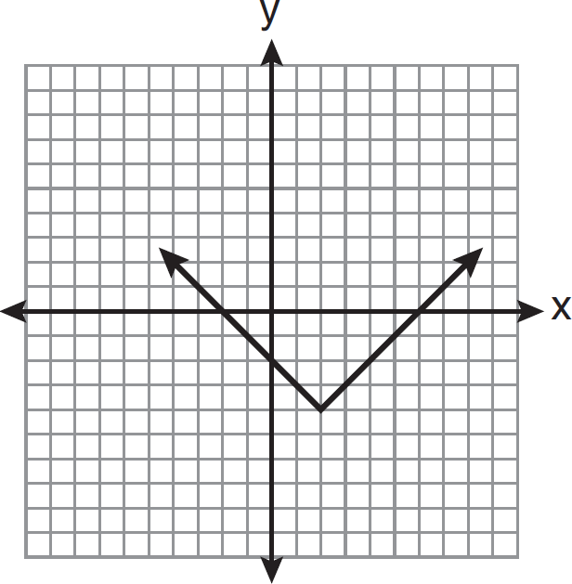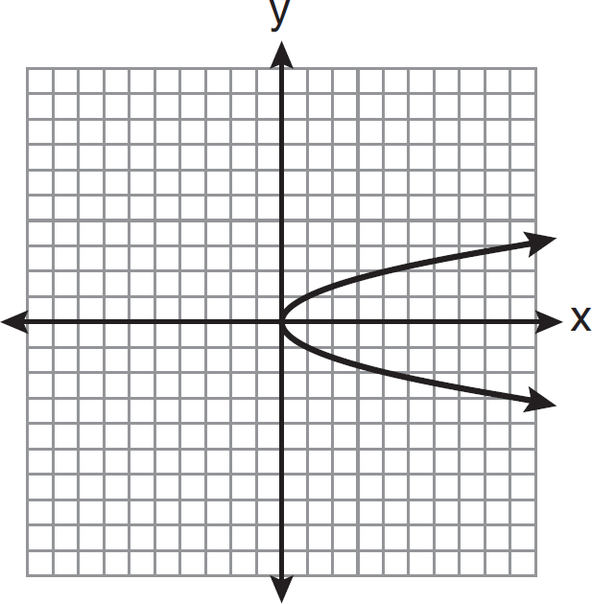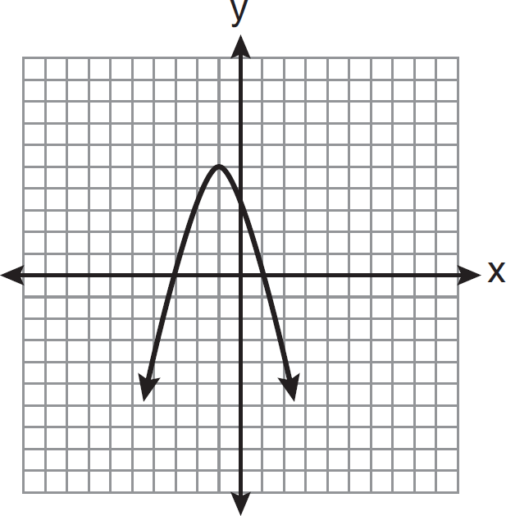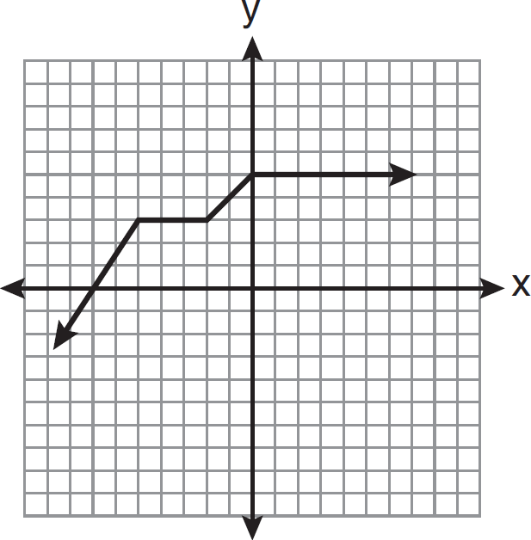

1. Which graph represents a function?
   1. B. C. D.

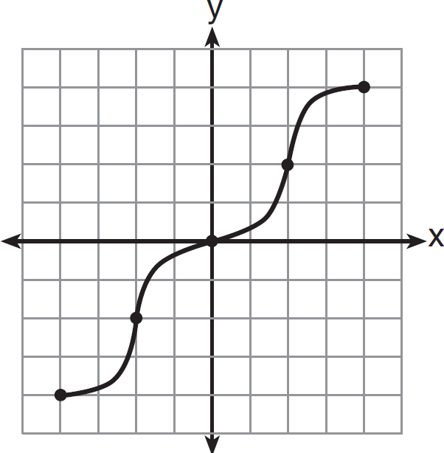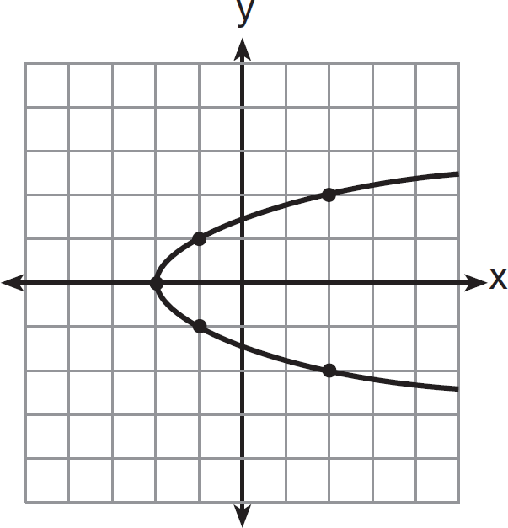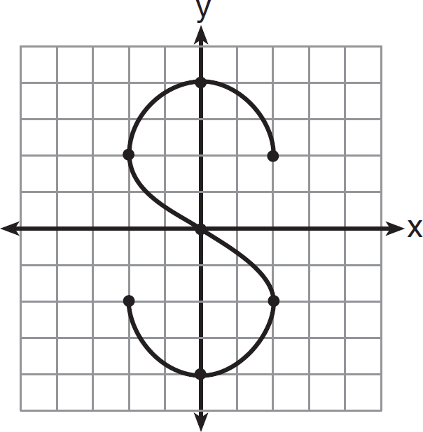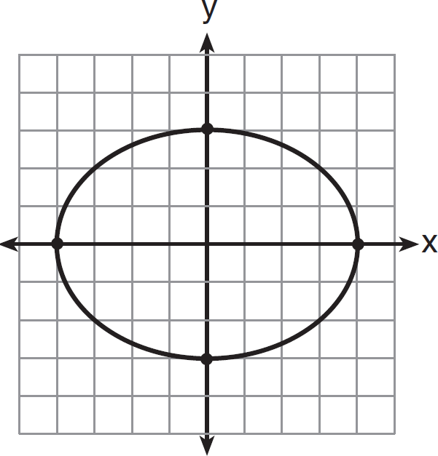

# HSE-Style Questions Aligned to CUNY HSE Curriculum Framework Section 4, Mathematics, Unit 3 – Rate of Change/Starting Amount

1. Hector makes a living by selling fish tanks. He gets paid a commission every time he sells a fish tank as well as a base salary that he receives every month. The equation *y* = 50*x* + 600 can be used to model his monthly salary, with *x* representing the number of fish tanks Hector sells in a month, and *y* represents Hector’s monthly salary. Which statement describes Hector’s monthly salary?
   1. He gets paid $650 a month.
   2. He gets paid $50 for every fish tank he sells plus $600 dollars a month as a base salary.
   3. He gets paid $600 for every fish tank he sells plus $50 a month as a base salary.
   4. He gets paid for 12 fish tanks.
2. The cost of riding in a taxi-cab in Center City can be modeled by the linear equation *y* = $3*x* + $2.75 where *x* represents the number of miles travelled in the taxi and *y* represents the total cost of the taxi ride. Which interpretation of this linear model is correct?
   1. The taximeter starts at $2.75 and goes up $3.00 for each mile that is driven.
   2. The taximeter starts at $3.00 and goes up $2.75 for each mile that is driven.
   3. The taximeter starts at $0.00 and goes up $3.00 for each mile that is driven.
   4. The taximeter starts at $0.00 and goes up $5.75 for each mile that is driven.
3. Marlene signs a lease for an apartment in 2014. Her monthly rent increases every year after the first. The equation

*y* = 150*x* + 1000 can be used to model her monthly rent, *y*, where *x* = 0 represents 2014. Which statement describes her monthly rent?

* 1. Her rent was $150 in 2014 and it is now $1000
  2. Her monthly rent was $1000 in 2014 and it has increased by $150 per year
  3. Her monthly rent was $150 in 2014 and has increased by $1000 per year
  4. Her monthly rent was $1000 in 2014 and it has increased 150 times each year

1. The function below can be used to predict the number of antibodies that should be present in a patient’s blood

*d* days after taking a particular medicine. f(*d*) = 60*d* + 100

Using the given function, how many antibodies are predicted to be in the patient’s blood after 11 days?

1. The function below can be used to predict the number of antibodies that should be present in a patient’s blood

*d* days after taking a particular medicine. f(*d*) = 50*d* + 90

After how many days would the function predict that the patient would have 440 antibodies in their blood?

* 1. 6 days
  2. 7 days
  3. 50 days
  4. 90 days

1. The table below shows the number of antibodies, *a*, in a patient’s blood *d* days after taking medicine A.

|  |  |
| --- | --- |
| *d* | *a* |
| 0 | 120 |
| 1 | 160 |
| 2 | 200 |
| 3 | 240 |
| 4 | 280 |

Which of the following equations models the number of antibodies in another patient that experienced the same daily increase in the number of antibodies, *a*, in their blood *d* days after taking medicine A?

A. *a* = 120*d* + 40

B. *a* = 40*d* + 90

C. *a* = 50*d* + 120

D. *a* = 280*d* + 40

1. The table below gives selected values for the linear function,

*f* *x*.

|  |  |
| --- | --- |
| *x* | *f* *x* |
| 12 | 18 |
| 13 | 20 |
| 14 | 22 |
| 15 | 24 |

Which of the following functions has the same slope as

*f* *x*?

* 1. *g* *x*  *x*  7

B. *h* *x*   2*x*  5

C. *q* *x*   2 *x* 18

3

*p* *x*  3 *x*  5

D. 2

1. The table below gives selected ordered pairs for the linear function

|  |  |
| --- | --- |
| *x* | *f* *x* |
| 20 | 5 |
| 23 | 7 |
| 26 | 9 |
| 29 | 11 |

Which of the following functions has the same slope as *f* *x*?

A. 𝑔 𝑥 = 𝑥 + 2

B. ℎ 𝑥 = 2𝑥 + 5

C. 𝑞 𝑥 = ! 𝑥 + 8

!

D. 𝑝 𝑥 = ! 𝑥 + 5

!

1. For the function 𝑔 𝑥 = 3𝑥 − 21, what is 𝑔(6)?
   1. -3
   2. 3
   3. 9
   4. 12
2. For the function 𝑓 𝑥 = ! 𝑥 + 14, what is 𝑓(18)?

!

*f* *x*.

* 1. 6
  2. 8
  3. 26
  4. 38

1. 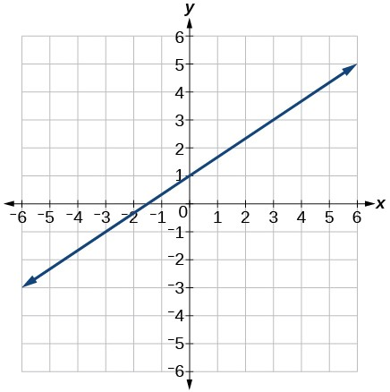Given the graph to the right, find f(-3).
   1. -6
   2. -1
   3. 3
   4. 4
2. The gas tank in a car holds a total of 16 gallons of gas. The car travels 75 miles on 4 gallons of gas. If the gas tank is full at the beginning of a trip, which graph represents the rate of change in the amount of gas in the tank?
   1. B.

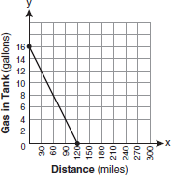 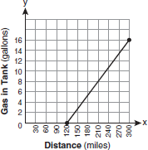

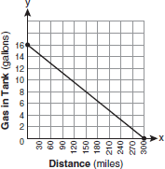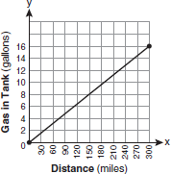C. D.

1. 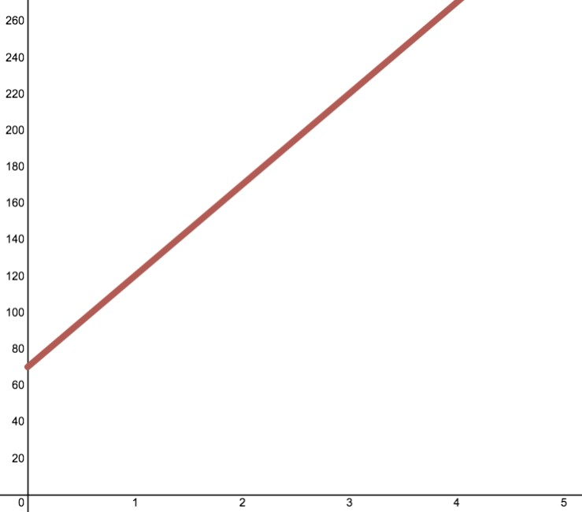The results of an experiment testing the effectiveness of a medication in raising the number of antibodies in a sample of blood are shown in the graph to the right.

Antibodies in a Sample of Blood

Which of the following functions correctly models the relationship between *d*, the days that have passed in the experiment, and *a*, the number of antibodies in the sample of blood?

A. *d* = 70*a* + 50

B. *d* = 50*a* + 70

C. *a* = 70*d* + 50

D. *a* = 50*d* + 70

Days Passed in Experiment

# HSE-Style Questions Aligned to CUNY HSE Curriculum Framework Section 4, Mathematics, Unit 4 – Systems of Equations

1. Eric and Nancy both sell fish tanks. Eric receives a monthly base pay of $1400, plus a commission of $75 for every fish tank that he sells. His total salary in a given month can be found using the function

*y* = 75*x* + 1400 where *x* is the number of fish tanks Eric sells and *y* is his total monthly salary.

Nancy, on the other hand, does not receive a base pay, but gets a commission of $250 for every fish tank that she sells.

Her total salary in a given month can be found using the function

*y* = 250*x* where *x* is the number of fish tanks Nancy sells and *y* is her total monthly salary.

Last month, Eric and Nancy each sold the same number of fish tanks and also earned the same salary. Which statement most accurately reflects the number of fish tanks sold and amount of money earned by Eric and Nancy last month?

* 1. Eric and Nancy each sold 8 fish tanks and each earned $2000.
  2. Eric and Nancy each sold 10 fish tanks and each earned $2500.
  3. Eric sold 4 fish tanks and earned $1700. Nancy sold 4 fish tanks and earned $1000.
  4. Eric sold 28 fish tanks and earned $3500. Nancy sold 14 fish tanks and earned $3500.

1. Consider this system of equations:

*y* = 75*x* + 1400

*y* = 250*x*

What is the solution to the system of linear equations?

**A.** *x* = 2000, *y* = 8

**B.** *x* = 1475, *y* = 250

**C.** *x* = 8, *y* = 2000

**D.** *x* = 4, *y* = 170

1. Eric, *E*, sold 18 more fish tanks than Nancy, *N*, last month. Together they sold 52 fish tanks.

Which system of equations can be used to find how many fish tanks they each sold?

* 1. *E* + 18 = *N*

*E* – *N* = 52

* 1. *E* + 18 = *N*

*E* + *N* = 52

* 1. *N* + 18 = *E*

*E* + *N* = 52

* 1. *N* + 18 = *E*

*E* – *N* = 52

1. A cellphone plan with CAMI Mobile will cost a client $80 a month plus $10 for each gigabyte of data that they use. The total monthly cost of using a cellphone under this plan can be calculated using the function

*f(x)* = 10*x* + 80

where *x* is the total number of gigabytes of data used during the month and *f(x)* is the total monthly cost.

A cellphone plan with FOIL Wireless will cost a client $60 a month plus $20 for each gigabyte of data that they use. The total monthly cost of using a cellphone under this plan can be calculated using the function

*g(x)* = 20*x* + 60

where *x* is the total number of gigabytes of data used during the month and *g(x)* is the total monthly cost.

Which of the following statements most accurately describes a comparison of the costs of using either CAMI Mobile or FOIL Wireless.

* 1. A customer that uses less than 2 gigabytes of data a month would pay less having a cellphone plan with CAMI Mobile than they would having a cellphone plan with FOIL Wireless.
  2. A customer that uses less than 2 gigabytes of data a month would pay less having a cellphone plan with FOIL Wireless than they would having a cellphone plan with CAMI Mobile.
  3. A customer that uses more than 2 gigabytes of data a month would pay less having a cellphone plan with FOIL Wireless than they would having a cellphone plan with CAMI Mobile.
  4. A customer that uses more than 2 gigabytes of data a month would pay more having a cellphone plan with CAMI Mobile than they would having a cellphone plan with FOIL Wireless.

1. Consider this system of equations:

*f(x)* = 10*x* + 80

*g(x)* = 20*x* + 60

What is the solution to the system of linear equations? A. (100, 2)

B. (90, 80)

C. (30, 140)

D. (2, 100)

1. A research scientist testing medicines determined that the following function represents the number of antibodies in a sample of blood from a patient after taking Medicine C:

C(*d*) = 40*d* + 80

In this function, *d* represents the number of days that the patient has been on the medication, and C(*d*) represents the number of antibodies in a sample of the patient’s blood.

The scientist then determined that the following function represents the number of antibodies in a sample of blood from a patient after taking Medicine E:

E(*d*) = 35*d* + 140

Which of the following statements is accurate?

* 1. After 40 days, the sample of blood from the patient that took Medicine C had 80 antibodies.
  2. After 35 days, the sample of blood from the patient that took Medicine E had 140 antibodies.
  3. After 560 days both samples of blood contained 12 antibodies.
  4. After 12 days both samples of blood contained 560 antibodies.

1. Consider this system of equations: f(*x*) = 40*x* + 80

g(*x*) = 35*x* + 140

What is the solution to the system of linear equations?

A. (12, 560)

B. (40, 80)

C. (35, 140)

D. (560, 12)

1. Consider this system of equations:

𝑥 − 2𝑦 = 10

3𝑥 + 4𝑦 = −40

What is the solution to the system of linear equations? A. *x* = 4, *y* = –7

B. *x* = –4, *y* = –7

C. *x* = 4, *y* = 7

D. *x* = –4, *y* = 7

1. Fred, *F*, can do 24 more pushups than Tye, *T*. Together they did a total of 73 pushups.

Which system of equations can be used to find how many pushups they each did?

* 1. *F* + 24 = *T F* + *T* = 73
  2. *T* + 24 = *F F* + *T* = 73
  3. *F* + 24 = *T F* – *T* = 73
  4. *T* + 24 = *F F* – *T* = 73

1. Fred, F, can do 18 more pushups than Tye, T. Together they did a total of 64 pushups. How many pushups did Fred do?

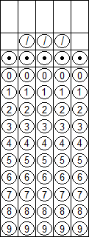

1. Joey, *J,* ate 18 more hot dogs than Kobayashi, *K*. Together they ate 129 hotdogs. Which system of equations could be used to find out how many hot dogs they each ate?

A. *J* + *K* = 129

* 1. *K* = *J* + 18

*J* + *K* = 129

C. *J* + *K* = 129

*J* = 18

D. *J* = *K* + 18

*J* + *K* = 129

1. 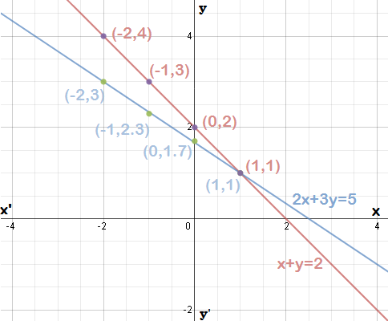The system of equations 2*x* + 3*y* = 5 and *x* + *y* = 2 are graphed at right.

Which of the following are true about the solutions to the system of equations shown?

* 1. The only solution to the system of equations is found at (1, 1).
  2. (-2, 4) and (-2, 3) are both solutions to the system of equations.
  3. There are 7 solutions to the system of equations.
  4. There is no solution to the system of equations.

1. 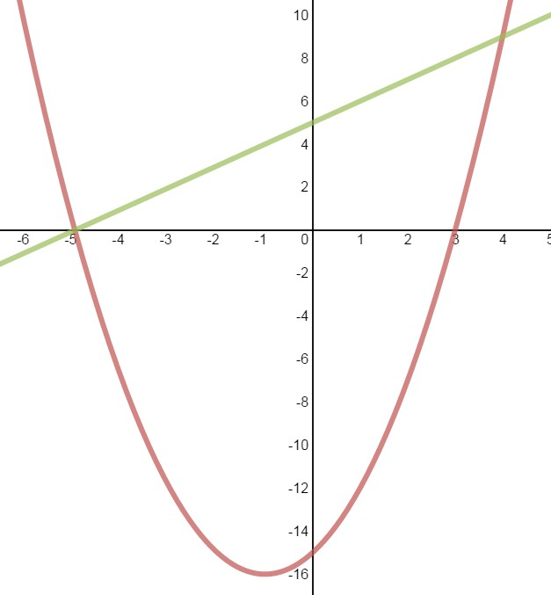The system of equations *y* = *x*2 + 2*x* -15 and *y* = *x* + 5 are graphed at right.

Which of the following are true about the solutions to the system of equations shown?

* 1. The only solution to the system of equations is found at (-5, 0)
  2. The two solutions to the system of equations are found at (-5, 0) and (3, 0)
  3. The two solutions to the system of equations are found at (-5, 0) and (4, 9)
  4. The three solutions to the system of equations are found at (-5, 0), (4, 9) and (3, 0)