The Handshake Problem
Each time the nine justices of U.S. Supreme Court meet, they all shake hands with each other.
Chief Justice Melville W. Fuller was on the US Supreme Court from 1888 to 1910. He started this custom, saying it showed “that the harmony of aims, if not views, is the court’s guiding principle."
There are nine justices on the Supreme Court. How many handshakes will result if each justice shakes hands exactly once with all of other justices?
Please show how you arrived at your answer.

The Handshake Problem
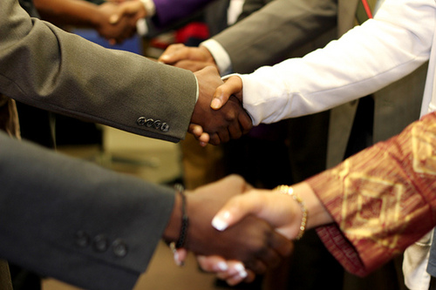
If there are 9 people in a room and every person shakes hands exactly once with all of the other people, how many handshakes will there be?
Show how you got your answer.

