**Azia, Travis, and Feliciano**

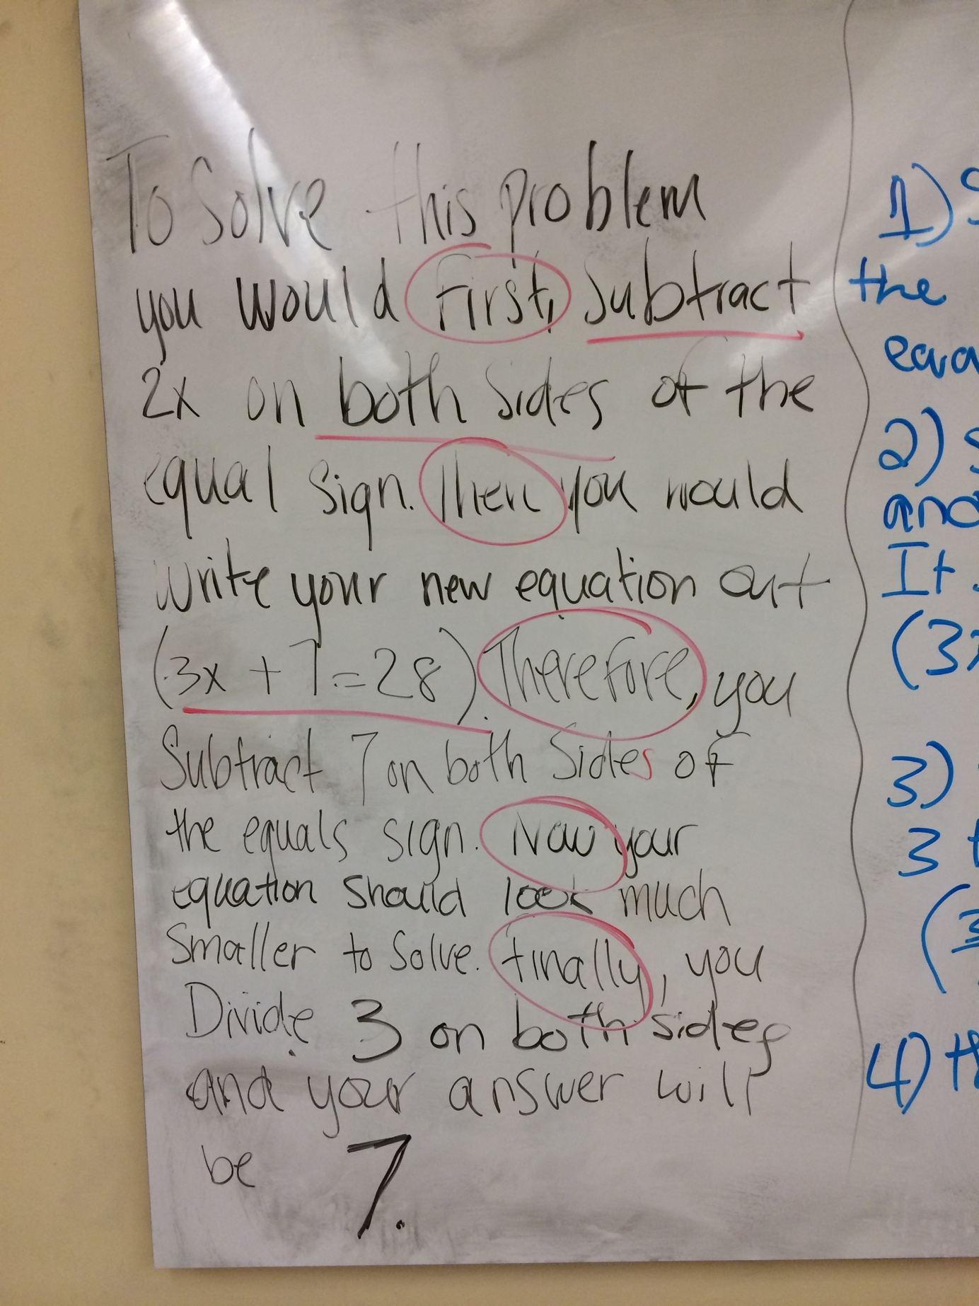

**Latoya, Imani, and Griselle**

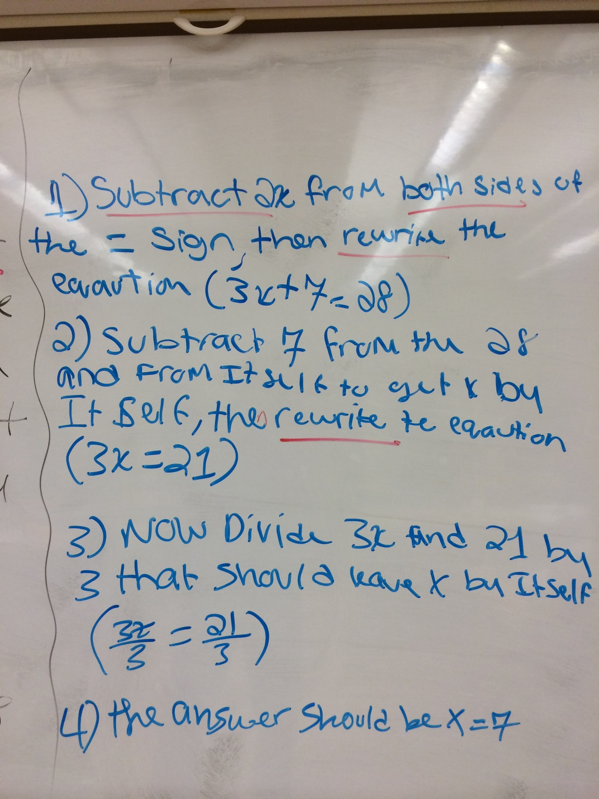

**Iman, Luis, and Krystal**

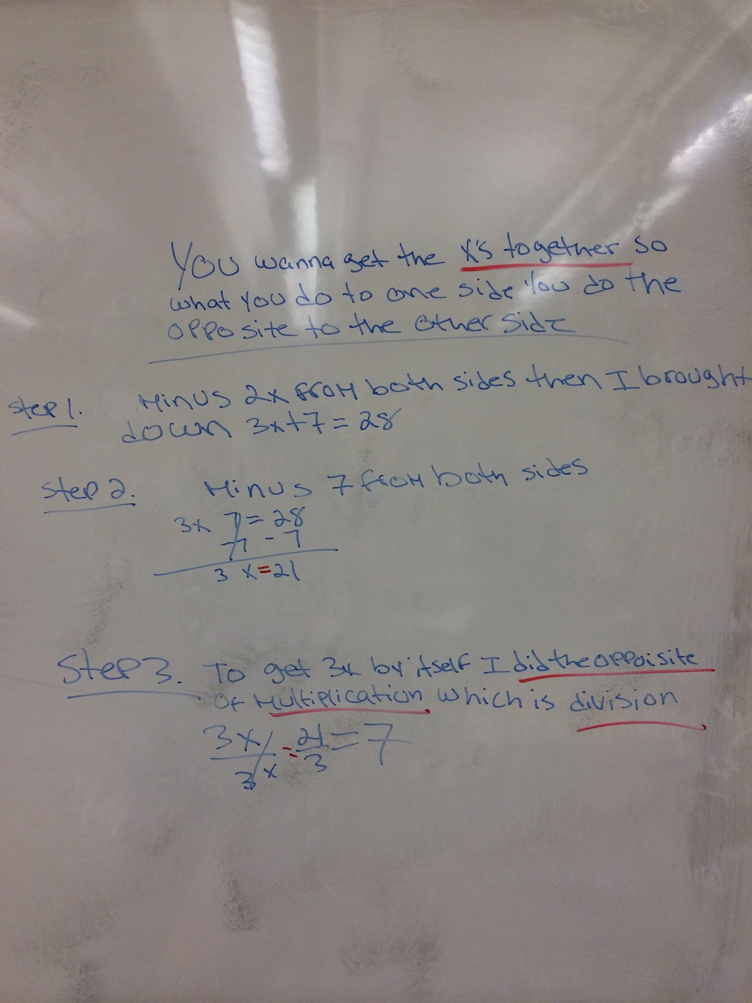

**Pedro and Jesse**

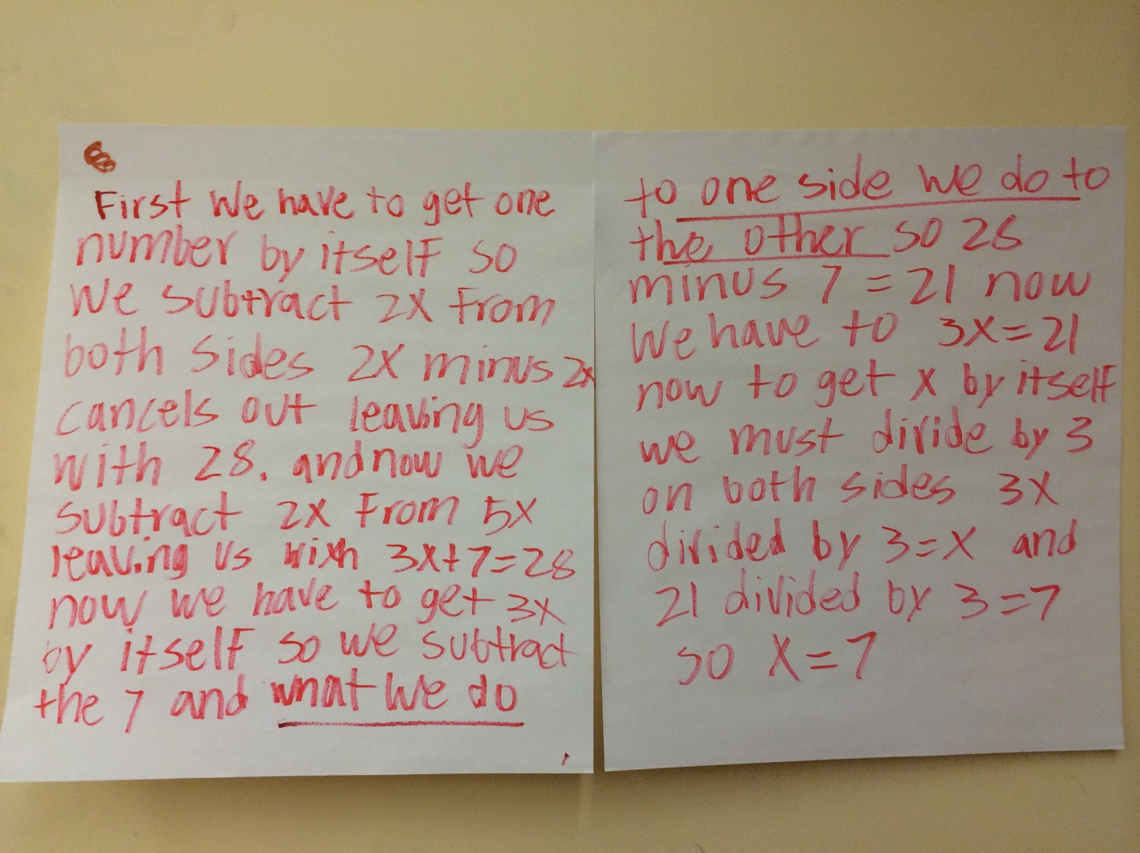

**Jaime, Jason, and Jhoana**

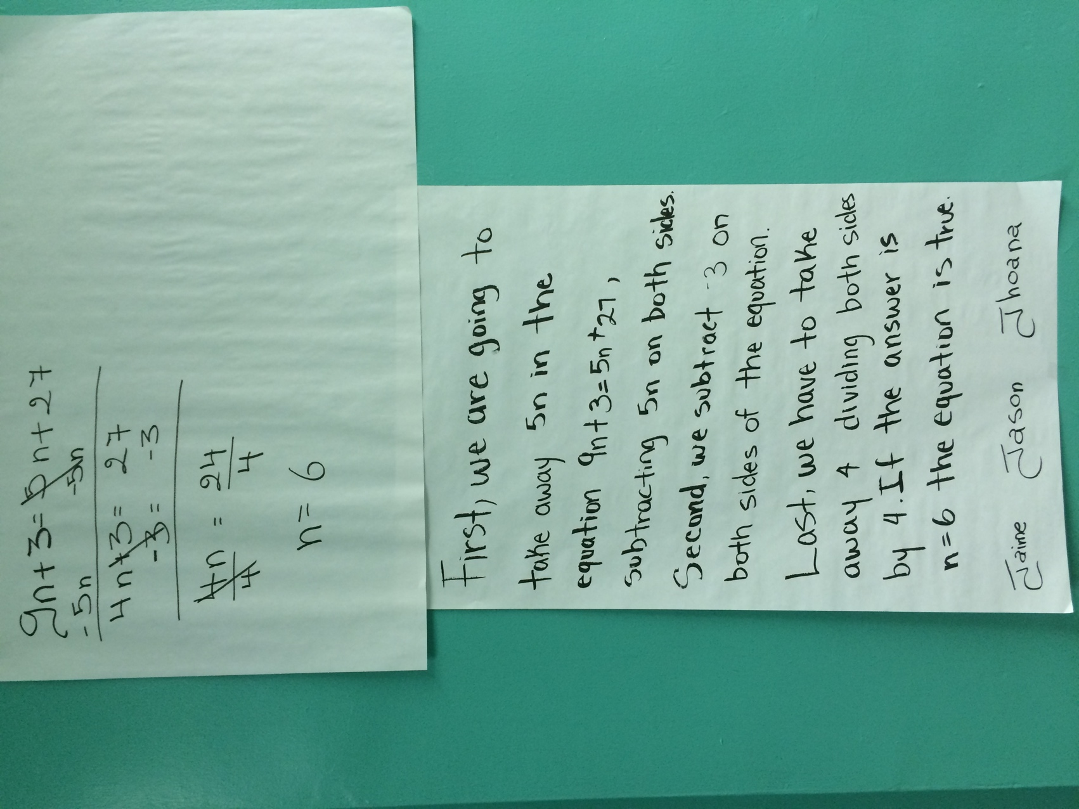

**Jose, Salvador, and Gabriela**

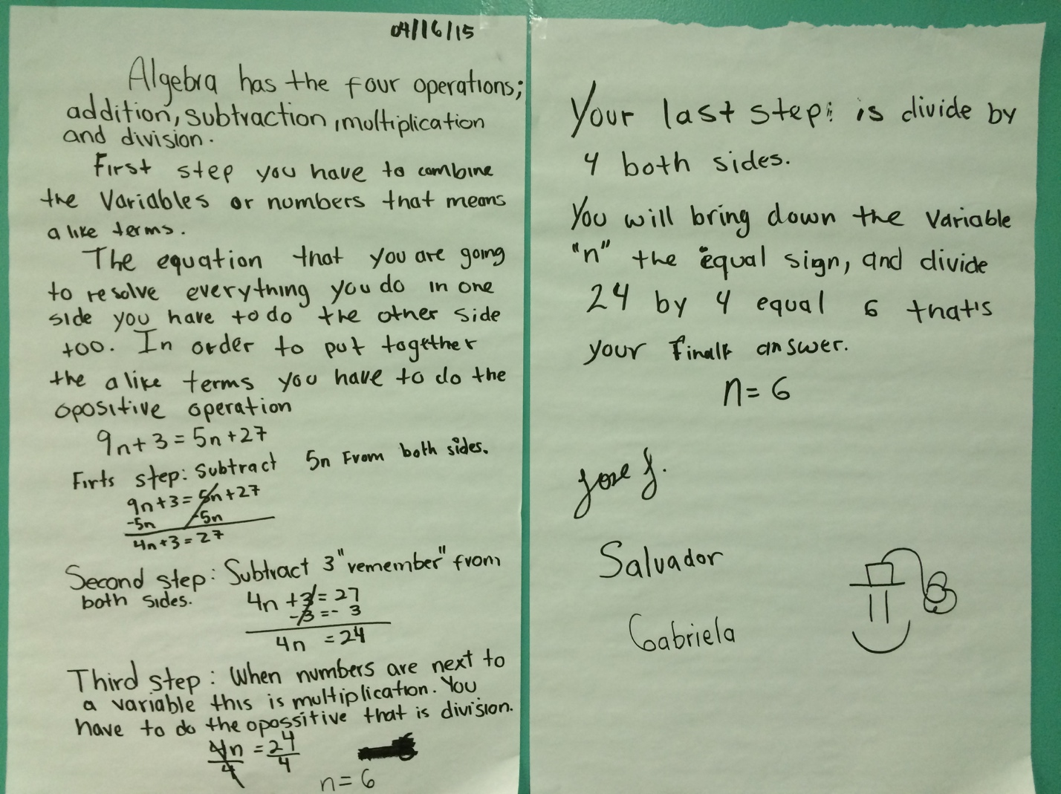

**Rosemary, Emmanuel, and Janet**

