Zip Zap Zowie Extension Activity

Jackie, Ervin, and Mark
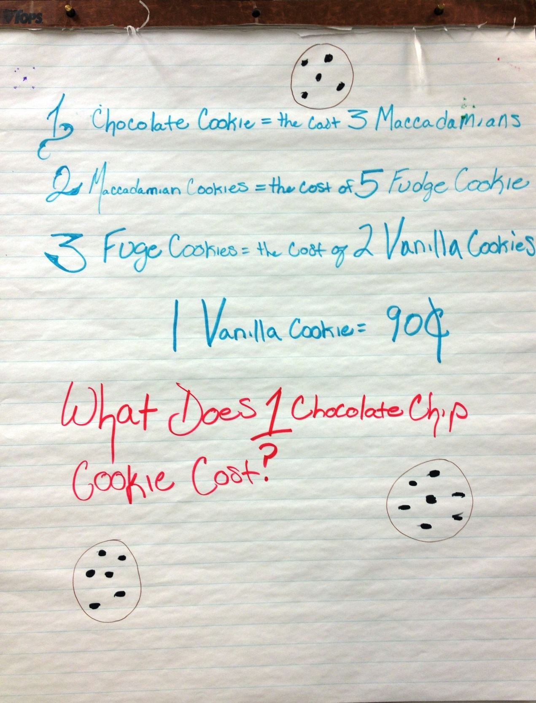

There are a few things I like about this extension activity. First, it required the students to think about how to make the conditions of the problem work when the chocolate chip cookie didn’t cost $0.60. They started with $0.50 and when that didn’t work, they randomly tried other numbers until they got to $0.90. This turned into an Aha moment as one student recognized that all of the cookie amounts stated would have to be factors of the chocolate chip cookie amount.

Also, one of the low-functioning students mentioned earlier, was able to participate in this group activity as the designer of the cookies on the chart paper.

Lastly, it provided opportunity for students who were outside of this group to solve this new problem. For example, Cindy solved the problem and I asked her to share her solution strategy with the class on the SMARTboard. She started by writing: 1 chocolate chip cookie = 3 Macadamia cookies and so on; but then, she decided that was taking too much time so she substituted variables to represent the cookies. Thus, again, the connection to abstract representation of real-life situations was made.

Cindy
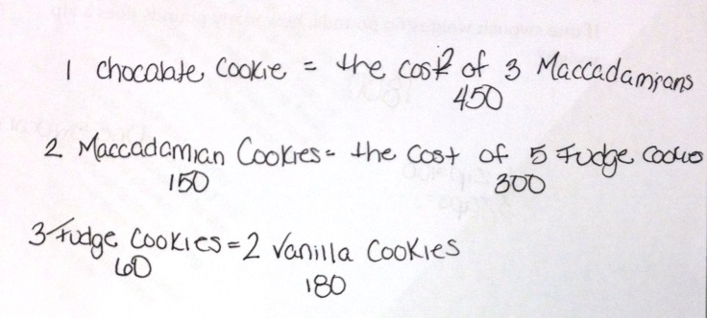
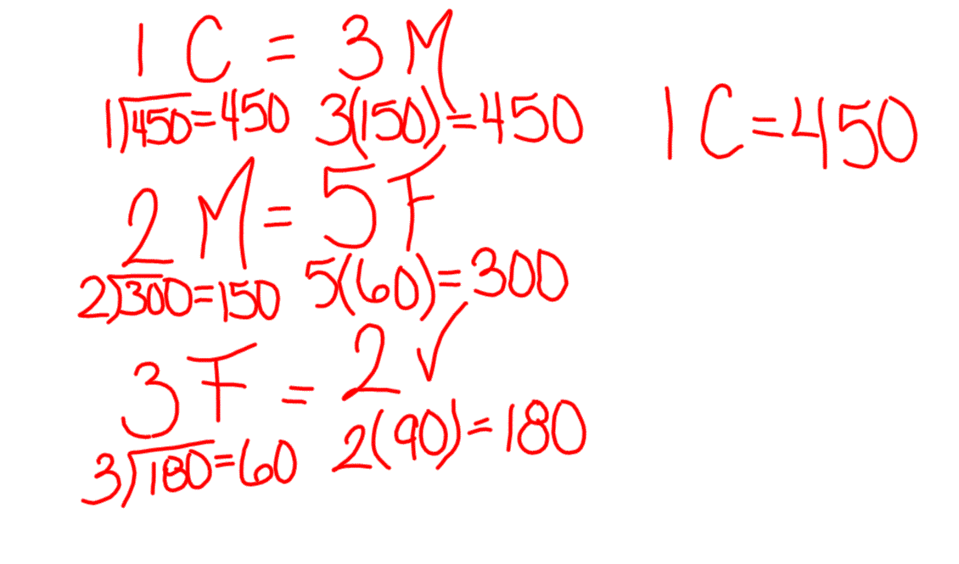

Pictured above is what Cindy presented to the
class using the SMARTboard.

Pictured on the right is how Cindy originally solved
the problem.

Cindy, Stephen, Craig, and Steven
