Complete the Pattern
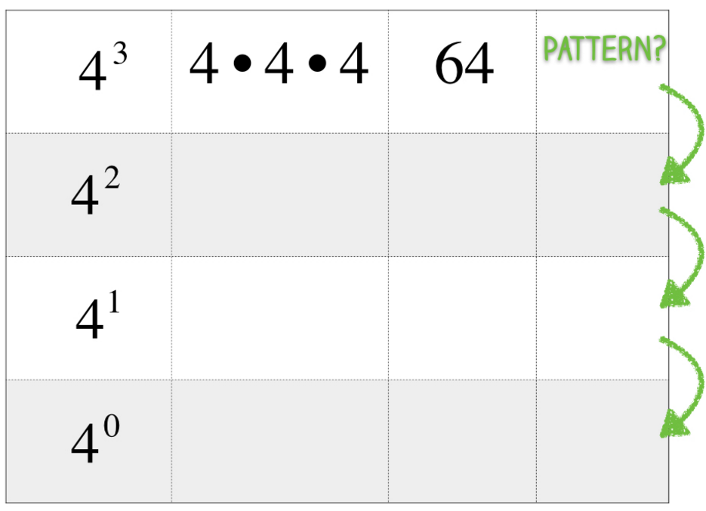
What do you notice?

Complete the Pattern
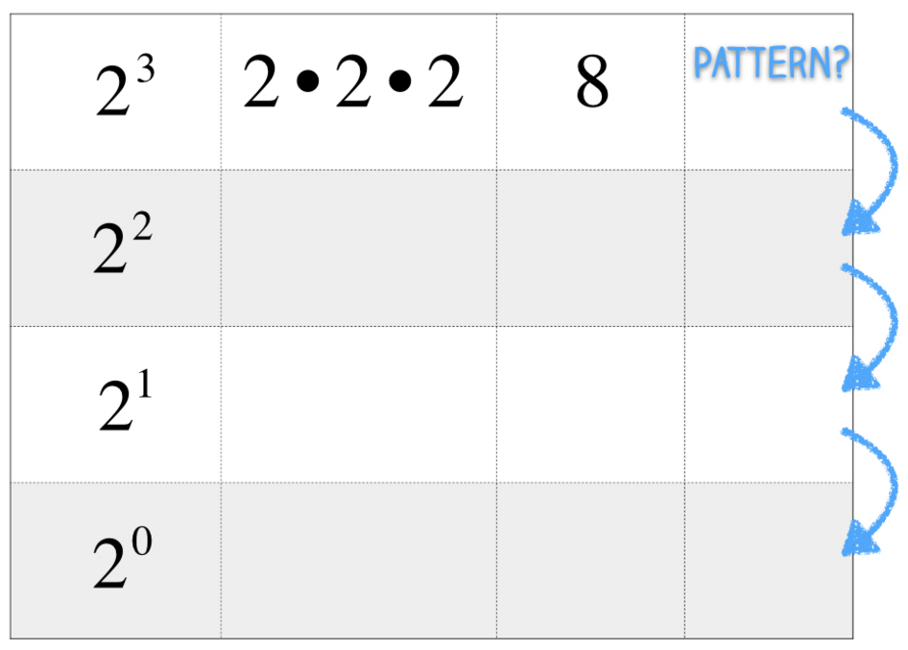
What do you notice?

Make a Prediction

What is the value of each of the expressions shown? How do you know?

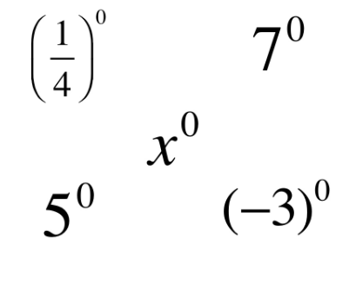

Make a Prediction

Do you think the expressions shown have the same value? Why or why not?
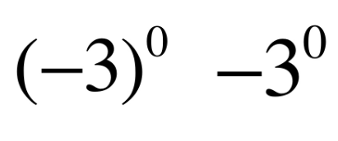

Complete the Pattern
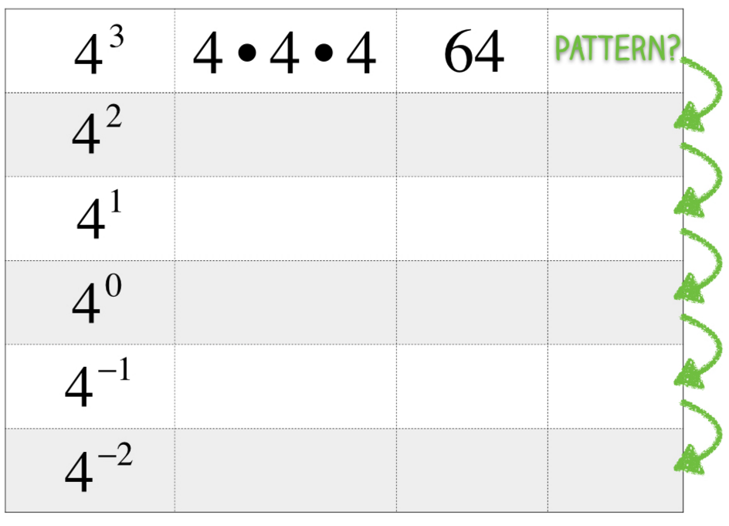
What do you notice?

Complete the Pattern

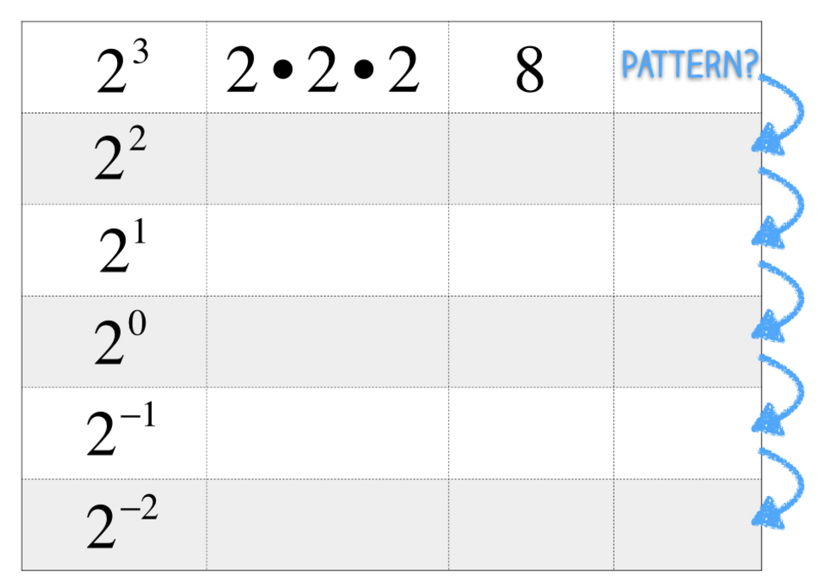

What do you notice?

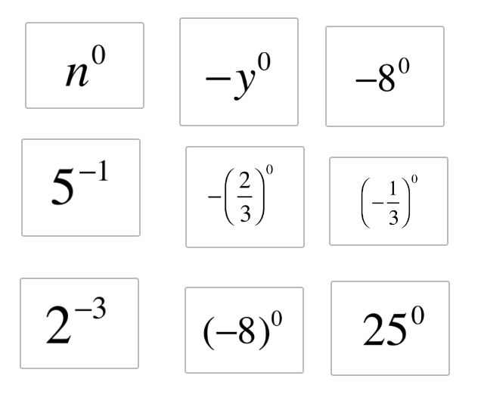
Re-write each expression in the appropriate column to show if it equals 1, -1, or a value between 0 and 1.
Expressions that Equal Values Between 0 and 1 | Expressions that Equal 1 | Expressions that Equal -1

Who Who is Correct?
Shelly and Michael each evaluated the same expression.
Who is correct? How do you know?
